Art Ideas 4
- Robots
Design you own robot – you could just use pencil and pen or add colour like these. See robot body part ideas at the bottom of this document.
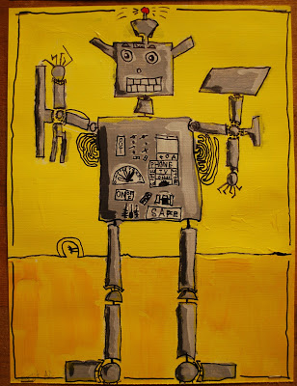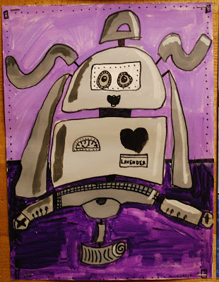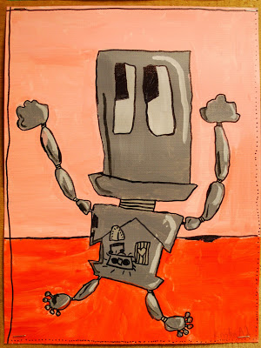

- Make your own invisible ink (no heating needed) – full instructions are www.researchparent.com/color-changing-invisible-ink
Materials:
- water (1/2 cup)
- baking soda (1 Tablespoon)
- paper
- Cotton bubs or a paintbrush to apply invisible ink
- rubbing alcohol (1/2 cup)
- turmeric (1 teaspoon)
- paper towels (or a paintbrush) to apply colour-changing solution

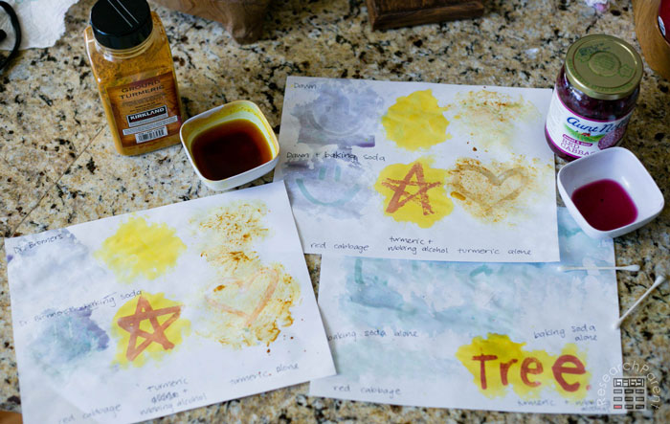

- Step by Step drawing instructions: Follow the link to get step by step instructions for drawing lots of things.
www.artprojectsforkids.org/my-drawing-tutorial-portfolio/drawing/
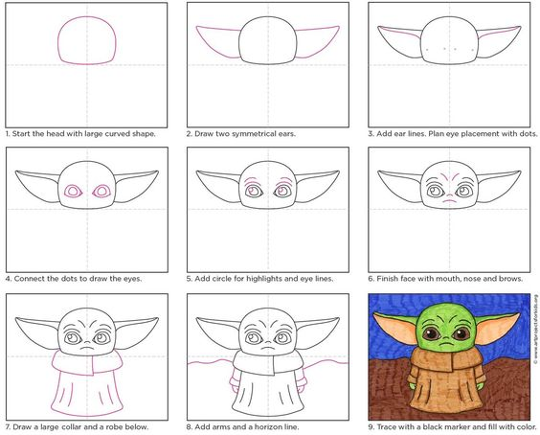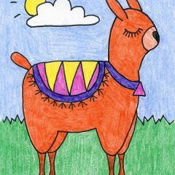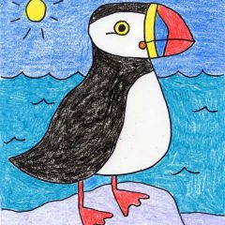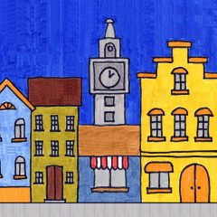
Toilet Paper Sculpture - Use up all those loo roll tubes! This is a fiddly activity but the results can look fantiastic. There are many tutorials on YouTube. Here are some of the better ones I found but feel free to explore with your parents permission.

www.youtube.com/watch?v=MMyChoWRcpU (This one has details about the artist Junior Frits Jacquet too then starts explaining the techniques at about 1.41 min)
www.youtube.com/watch?v=F6b1lXQzogs
www.youtube.com/watch?v=XvL9lD4G56M

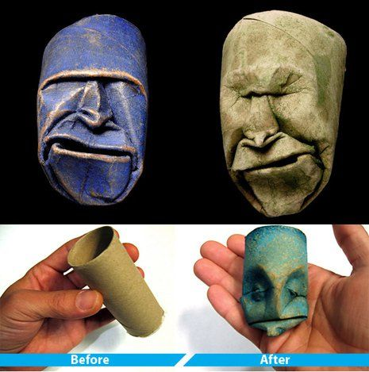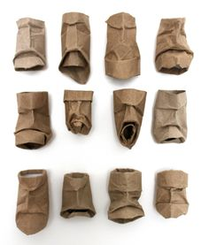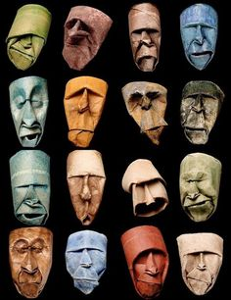

- Graffiti Tags – Draw your name in large, thick and chunky font and fill with different patterns. Add colour if you want.
There are two different graffiti backgrounds you can use in the documents section to print out or you can make your own.
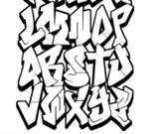
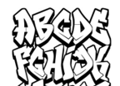
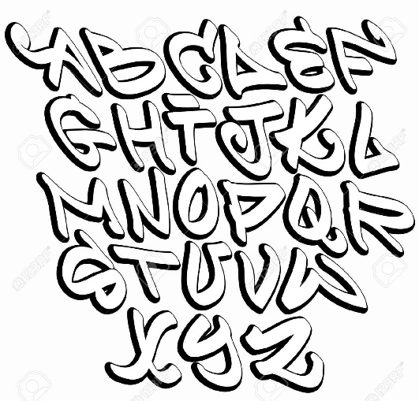
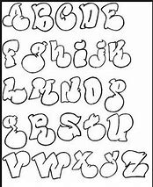
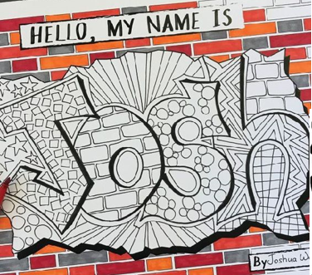

- Circles, circles everywhere
Find something circular to draw around. Create lots of circles on any type of paper and fill with any type of pattern you like. You can add colour if you want. Here are some ideas to get you started.
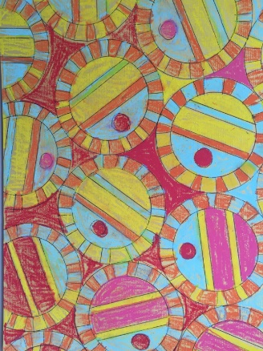
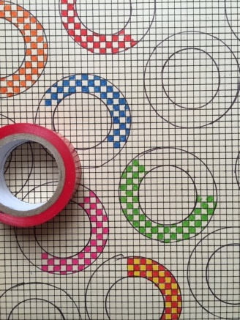
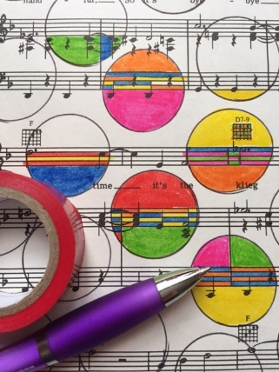
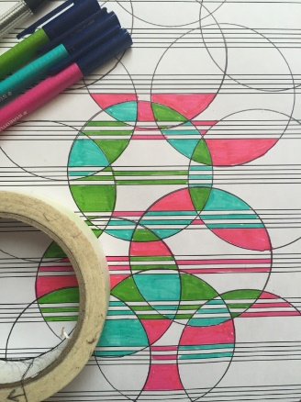
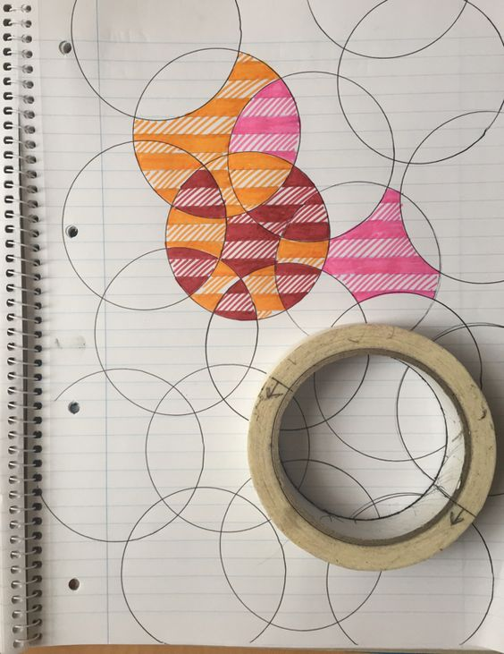

- Flower Power
The background is made up of layered tissue paper!

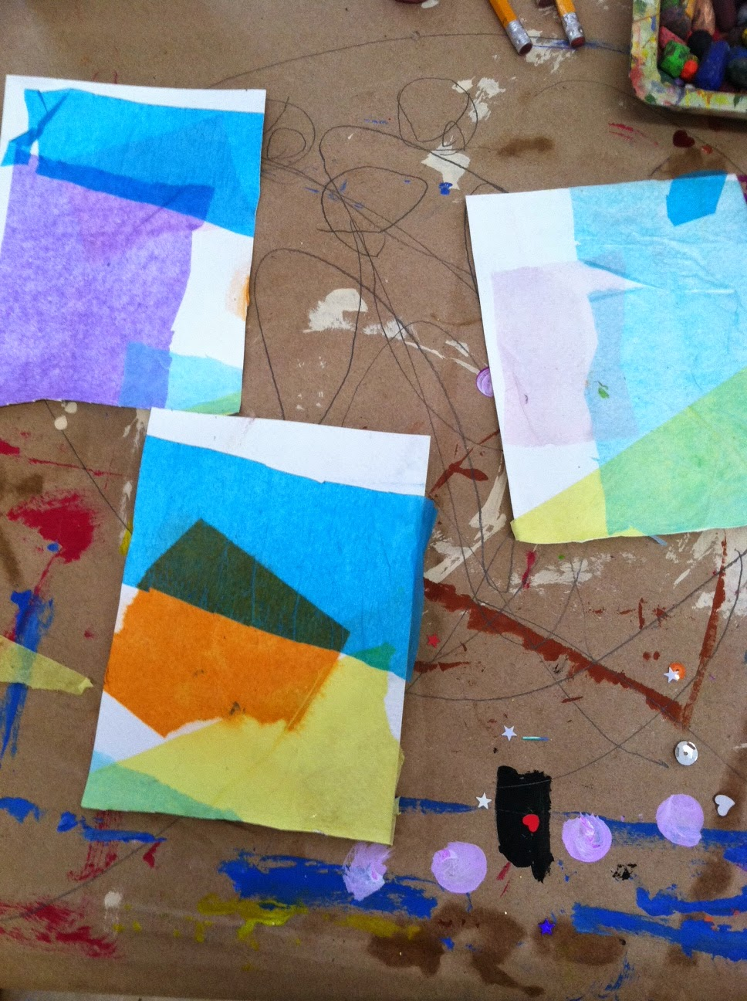
The centre of each flower can be stamped, using sticker back foam mounted on cardboard or you can use a cardboard petal stuck on a cardboard base. Alternatively, just paint the petals on in bright colours. You could add some fabric scrap petals too.
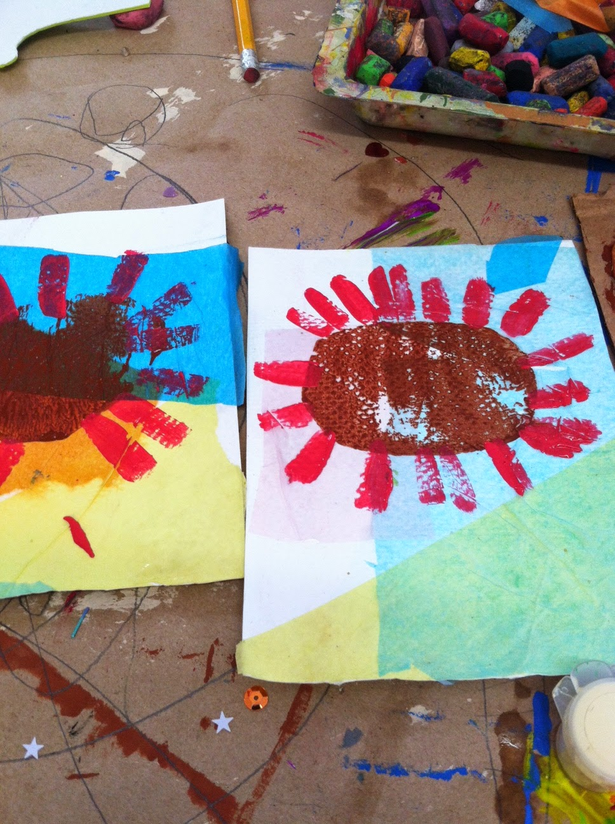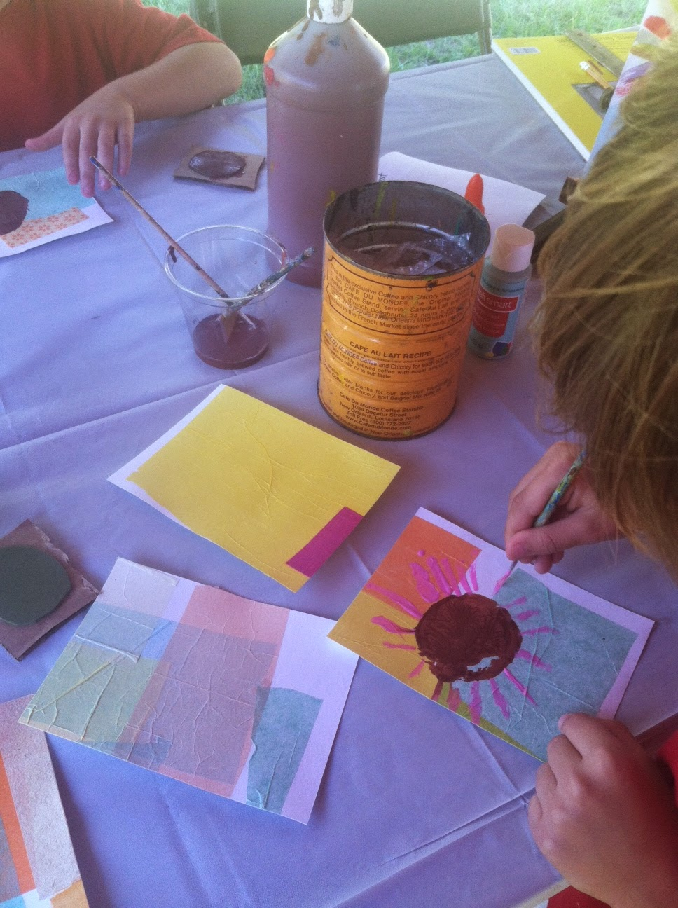
The centre of the flower is printed using bubble wrap.

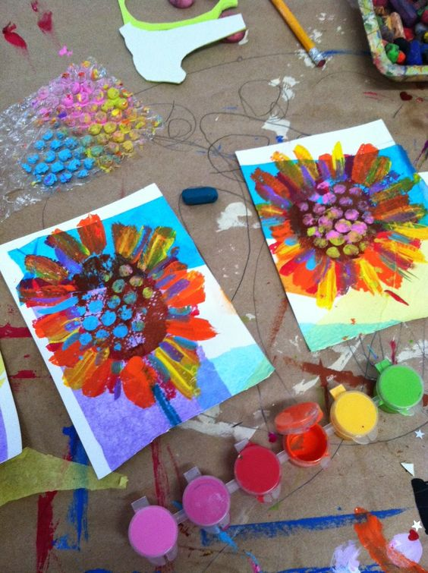

- Dragon Eyes: Follow the steps at the end of this document to create your own dragon eye. Study pictures of real animal eyes before you start. Look closely at the area around the eye and ther colours inside.
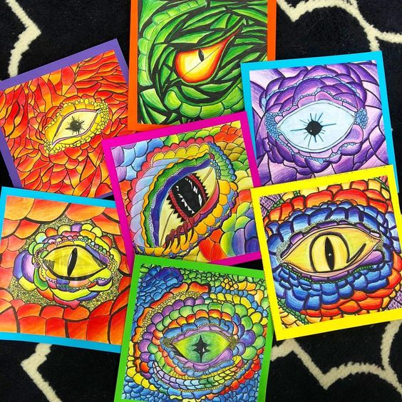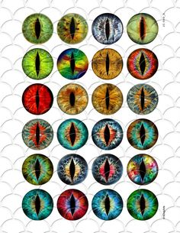

- Snails and other animals
Create random circles, L shapes or other random shapes out of paint. Once dry add details in pen.
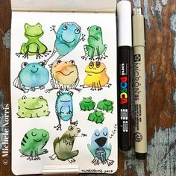
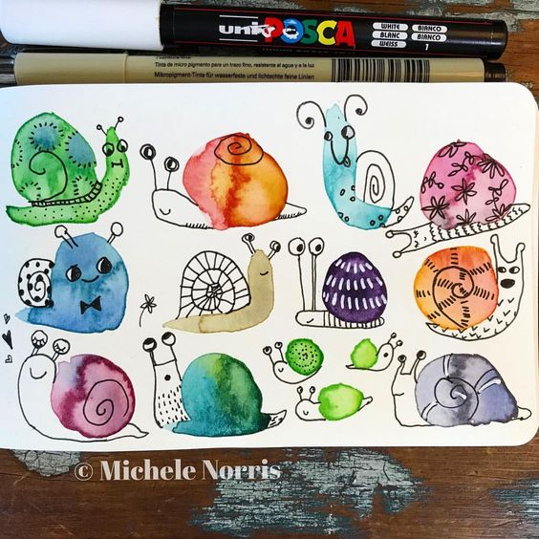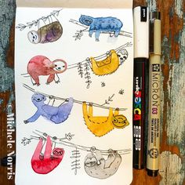

- Try out the ideas on Wow Art on YouTube.

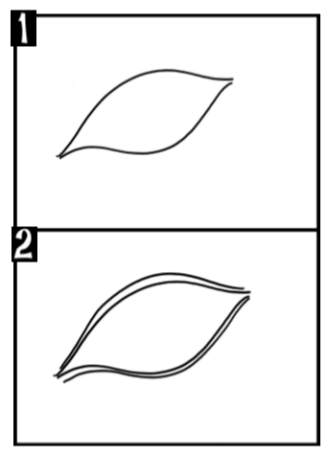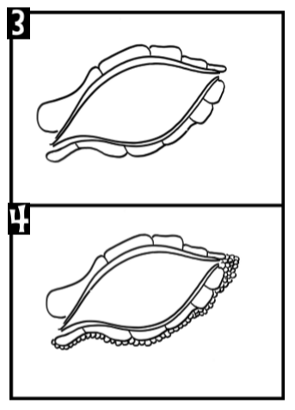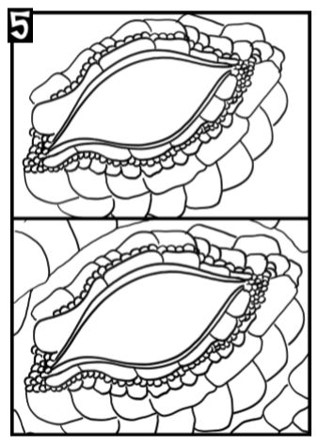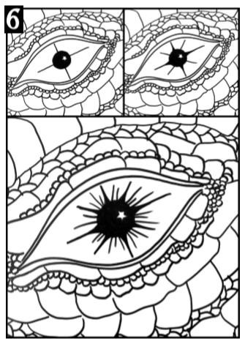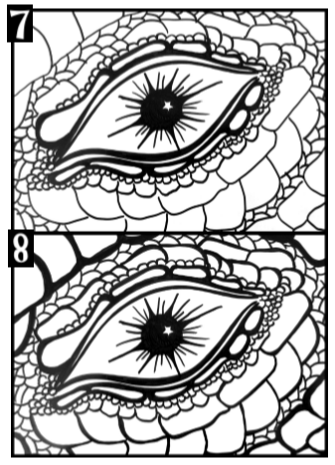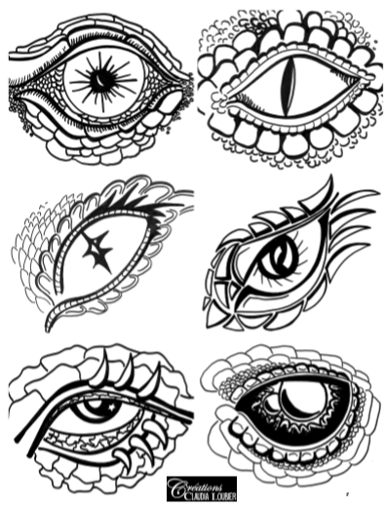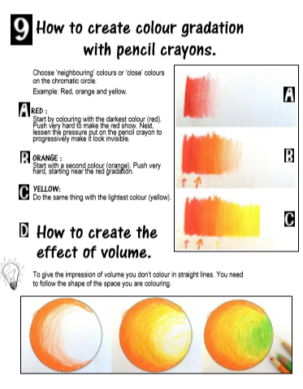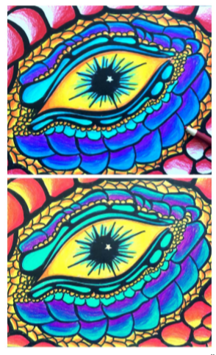
Created by Créations Claudia Loubier
Created by Créations Claudia Loubier

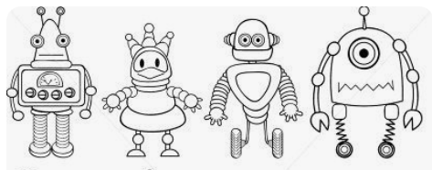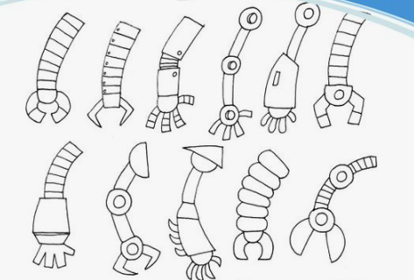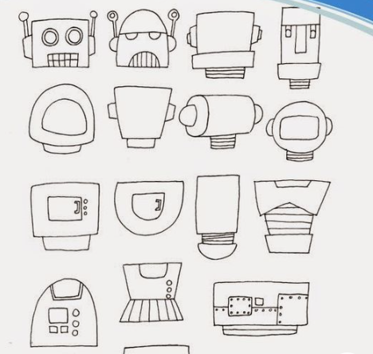
Robot Ideas

