Art Ideas Bank 5

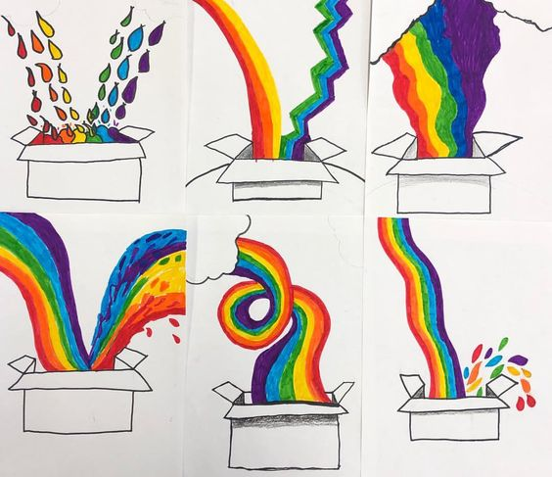
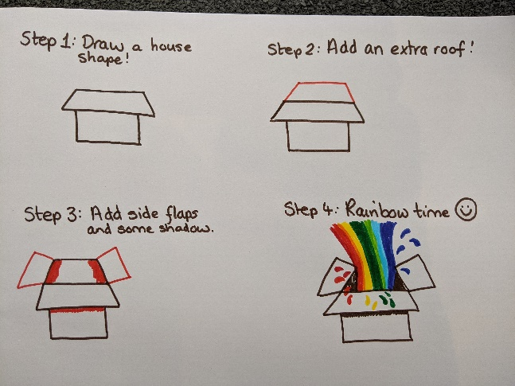
Rainbow box

Ostrich madness!
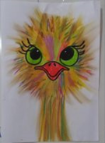
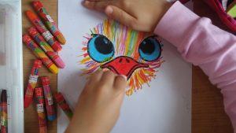
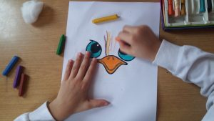
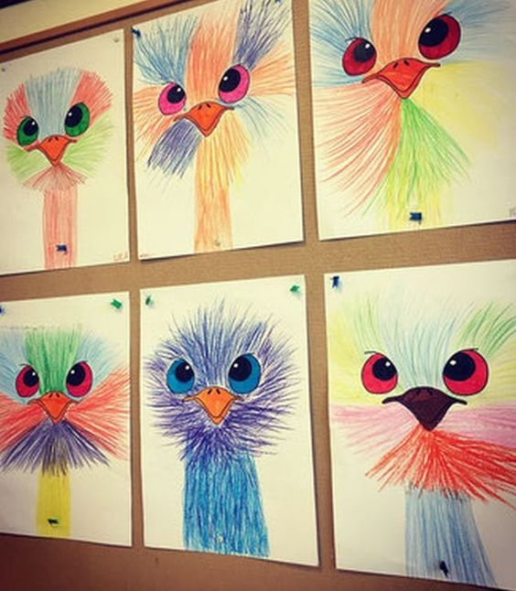
Use this template for the eyes/beak or draw your own. Using different coloured felt tips or pencil crayons add the feathers in outwards strokes. You can keep the colours in blocks or go multi-coloured!
ostrich-art-activity-template-for-kids.jpg (1074×677) (preschoolcrafts.us)

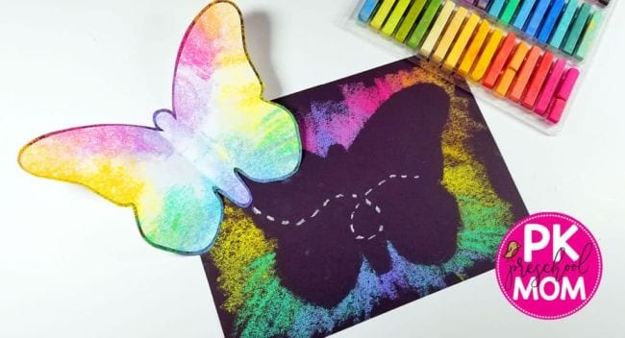
Chalk Butterflies
Print out a butterfly shape or draw it out freehand. Cut it out and place on a piece of black (or coloured paper) then, holding it in place, use chalks from the edge of the template outwards.

See the end of the sheet for I spy games.

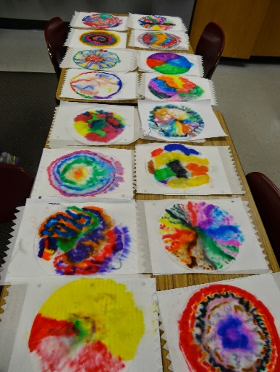
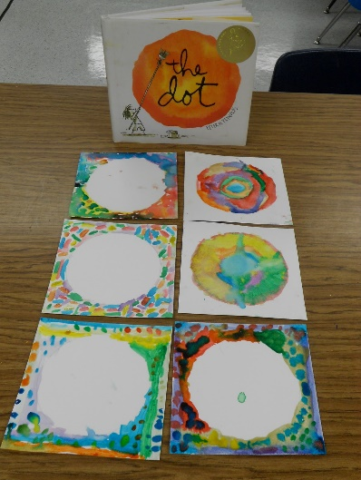
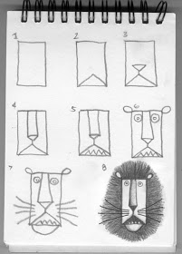
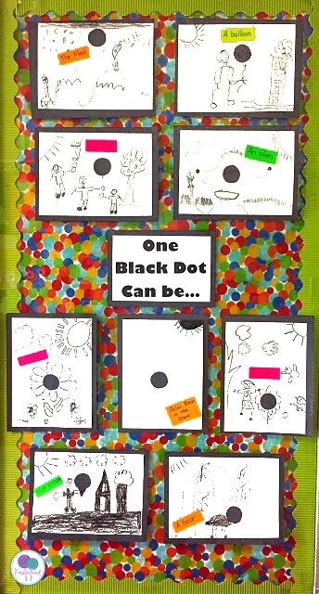
The Dot

The Dot by Peter H. Reynolds | Read aloud Book for kids - Bing video – listen and watch the story.

Create your own ‘dot’
Where could your dot be? Draw it in a background.

If you want more dot ideas have a look here - Tales from the Traveling Art Teacher!: Celebrating International Dot Day! (talesfromthetravellingartteacher.blogspot.com)

Draw a lion!
Add a rectangular body, legs and a tail. Create a
background for him.

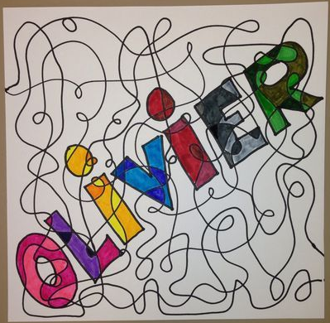
Name Scumbling!
Write you name in large chunky letters (at least 1 finger width thick) across the page. Create a single, long line that wanders all over the page, which loops and has lots of changes in direction. Make sure it crosses your name to split it up into sections.
Now colour in just the parts inside your letters. You could use different shades of each colour like the example below or do it however you like. You could even add patterns like in your 3,4,5 or 6’s!

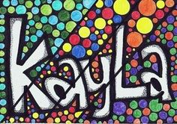
Other ideas you could go for.
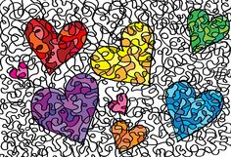

Op Art – very effective but very easy to do
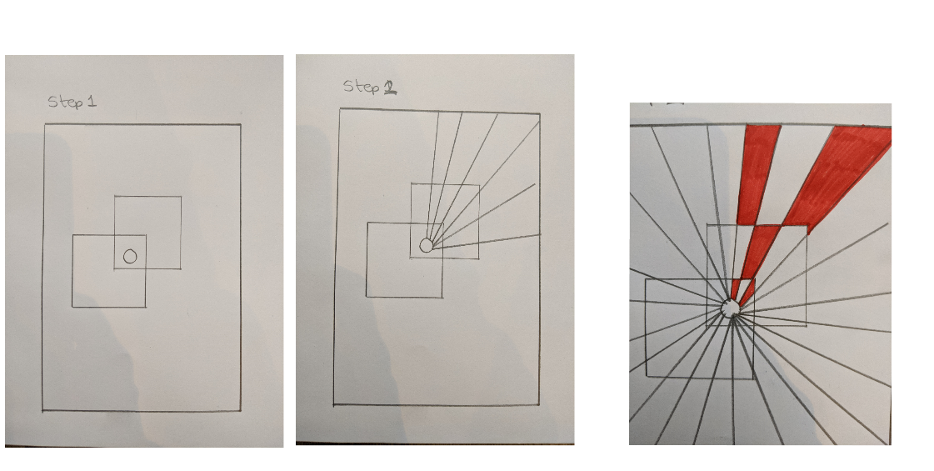
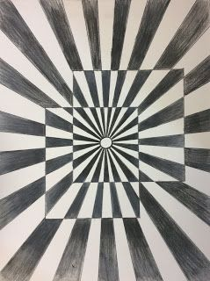
Try this video for another similar idea (start at 2.15). It is aimed at teachers but is really good for kids too.

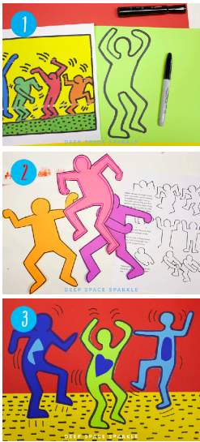
Keith Harding Project

STEP ONE: Look at the examples of Keith Haring’s art below. Practise drawing the different figure shapes or even better - create your own poses.

STEP TWO: Use a black felt-tip to draw 3-5 figures on coloured paper. You can do this in pencil then go over in pen.
(You can make your own coloured paper by painting a plain sheet.)

STEP THREE: Cut out the figures you like and glue onto a background. You can make the background out of more coloured paper / newspaper, you could draw your own background, add patterns. Anything!

STEP FOUR: Once the background and figures are glued, use the black felt-tip to create MOVEMENT lines within the art. These expressive lines are very effective in bringing the art to life.

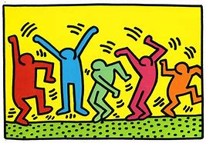

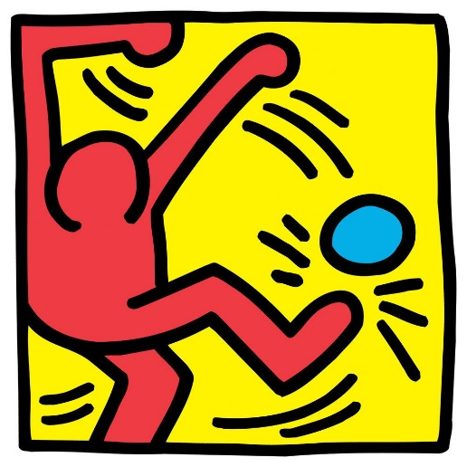
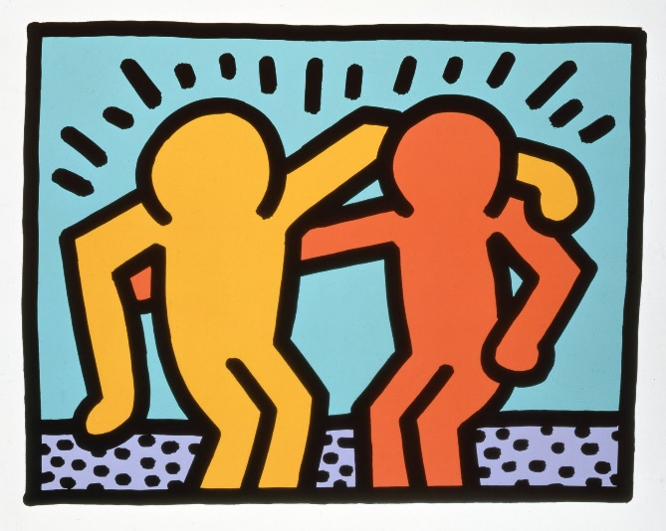

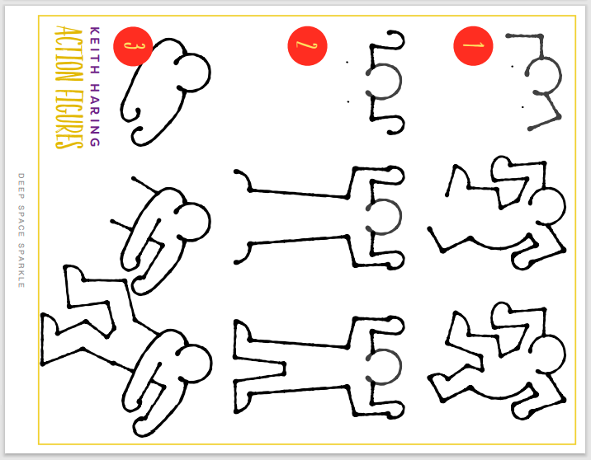

Some examples from other children
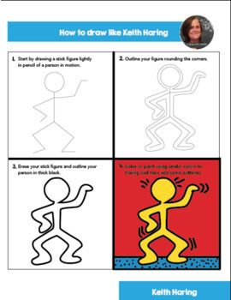
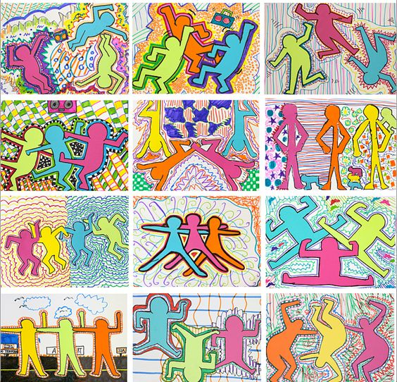

Draw a Romero Britto Cat

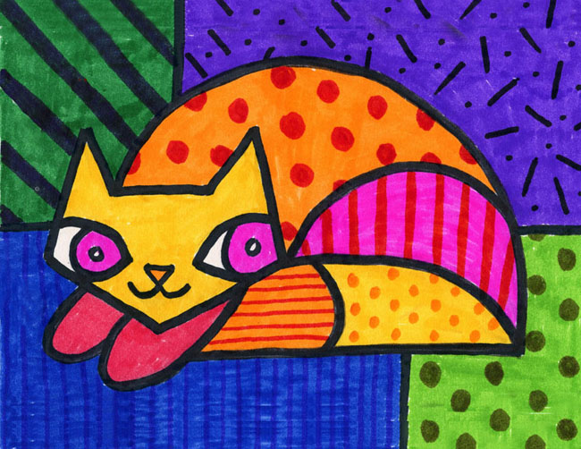

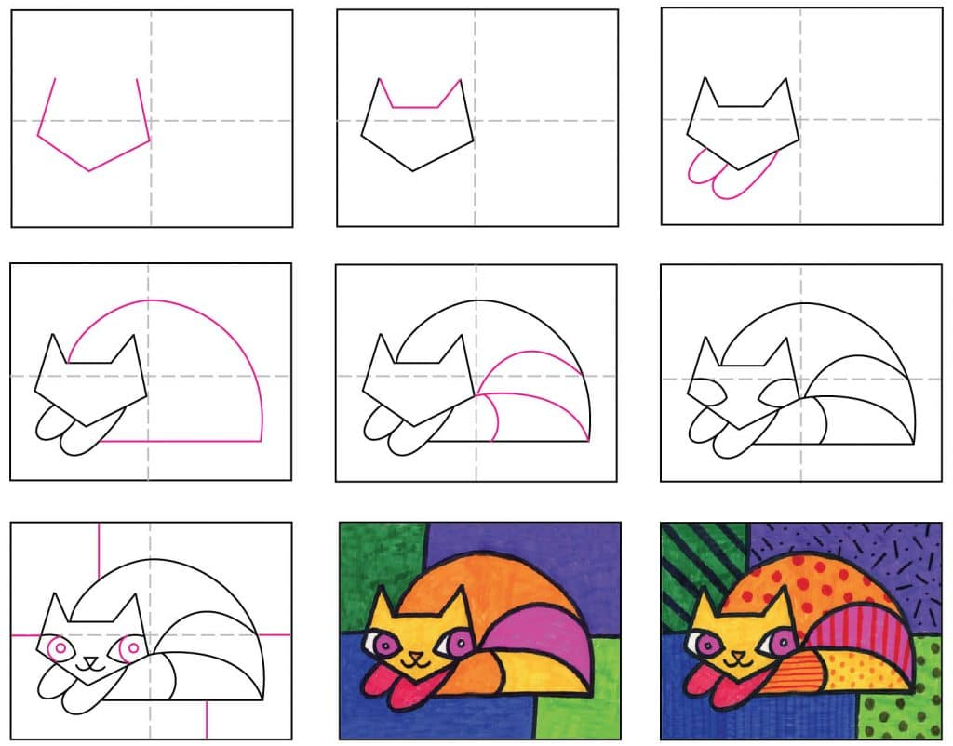
You could use paint, felt-tip, pencil crayon or collage.



