Hello, here are some great ideas to have a go at. Most need very little resources, just pencils, pens and paper.
Pick one idea to have a go at:
- Mondrian Shapes
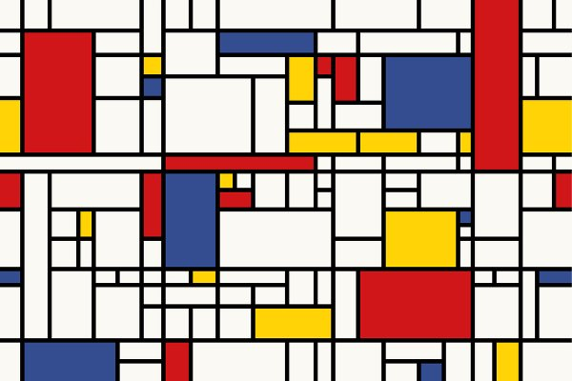
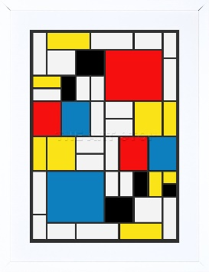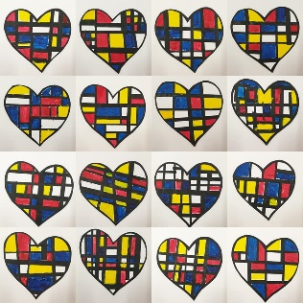
Look at Mondrian’s work (2 examples on the left). Draw a shape on a piece of paper. Use black thin and thick vertical and horizontal lines to draw a grid on it. Colour in some of the rectangles in primary colours (red / blue and yellow). Leave some areas blank. Cut out your shape. You could add lots of different sized ones together and create an interesting composition.

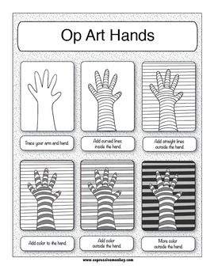
- Optical art
Look at the work of Bridget Riley. Some of the designs make your eyes
go funny! Create your own optical illusion hand print.
(Or it could be any shape).
- Draw your hand on a piece of paper
- Draw curved lines over the hand
- Use a ruler and join the lines in the hand to the edges of the page
- Colour in each layer
- The hand should look like it’s raised up!
There are loads of YouTube videos to show you how.

What other visual illusions can you create?
See M. S. Escher’s work to inspire you!

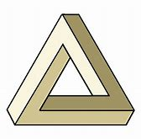
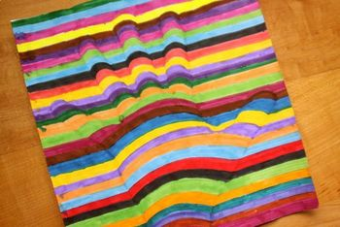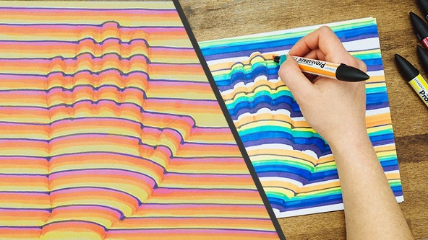

- Musical inspiration
Listen to any piece of music. Draw the pattern of how it makes you feel. Use the colours it makes you think of. Try it again with a totally different piece of music. Wassily Kandinsky did this a lot.
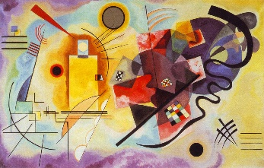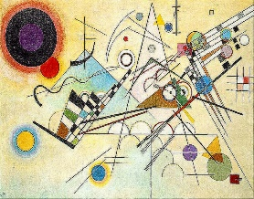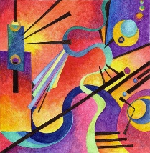
- Matisse Hearts
Look at the work of Henri Matisse. He cut shapes out of coloured paper and created a design, sticking them down. You can use any bits of coloured paper you can find, or colour in plain paper (even envelopes) and cut them up.
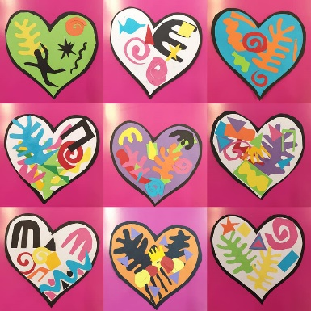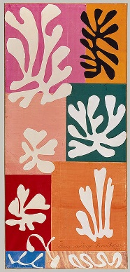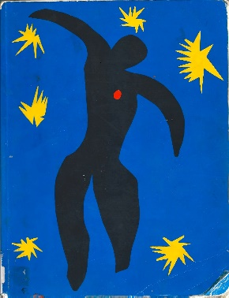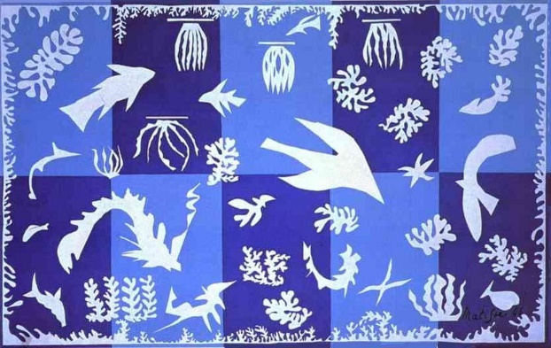

- Henri Rousseau Landscapes
Rousseau created wonderful pictures of tropical rainforests but he never actually visited one. He got all his ideas from books and looking at tropical plants. Use the internet and plants you can see in your garden to create your own landscape designs.
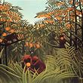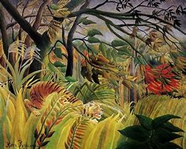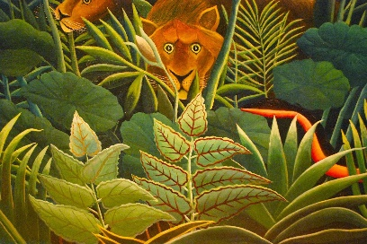

- Artist / Art Work research
Research an artist or an art work (e.g. painting / sculpture) on gallery websites e.g. The Tate, The National Gallery, MONA, Google Arts and Culture (artists)
- Create your own version of your favourite piece of work
- Write up a biography of your chosen artist
- Look at 2 artists, explaining how they are similar and different
- Create a fact file about an artist / art work
- Make your own set of top trumps using artists or art works. How many points would you give each out of 100 and what categories would you have?
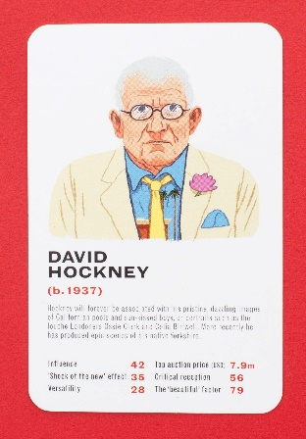
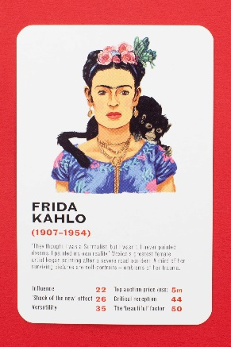
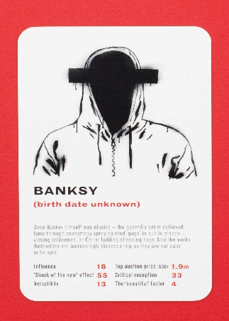

- Things to Draw!
You can literally draw anything. Here are some ones you could get started with.

- Close up of your pet
- a cupcake (the eat it!)
- your bike
- a house plant
- eyes (use a mirror to see all the detail)
- something from your pencil case
- the clothes you dropped on the floor (Now pick them up and put them in the dirty clothes basket!)

- a shoe
- a leaf
- a landscape (made up or real)
- what you ate for dinner/lunch or breakfast
- some keys
- the view from your window
- a chair
- a biscuit
- a piece of pasta
- something from your favourite TV programme
- a made up landscape
- a fork
- some socks
- a wrapped chocolate bar (then open it, take a bite and draw it again, then draw the empty wrapper)
- a button
- a glass of water

- Painting with Coffee
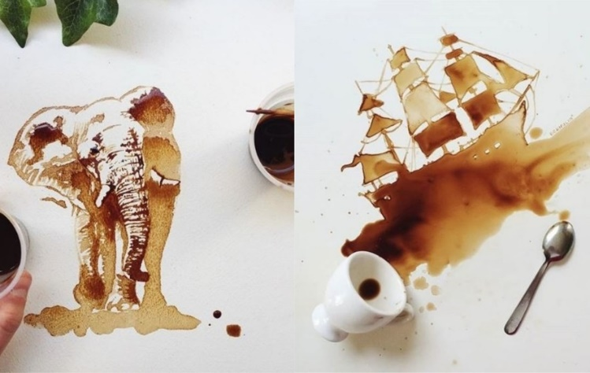
Look at the art work of Giulia Bernardelli. She paints pictures with cold coffee. Mix some strong coffee up and leave it to cool. Use a spoon (or anything) to spill it onto a piece of paper. What does the ‘splodge’ remind you off? Use a brush or toothpick (end of a pencil etc) to turn it into a picture.

- Design a dream house
- What does it look like on the outside?
- What is in the garden?
- What does your room look like?
- Imagine inside your room is a magic door that can take you anywhere. Draw/describe where it takes you.

- Pencil rubber pointillism
Use a pencil with a rubber on the end. Dip it in paint and dab away. You could do this with an Australian aboriginal theme, using one of the dreamtime stories. (See YouTube videos). If you don’t have paint you could make some by using.e.g coffee, tea, squishy old raspberries/blueberries etc, various powders e.g. mustard etc (See funkidslive.com)
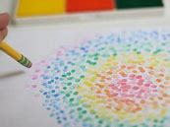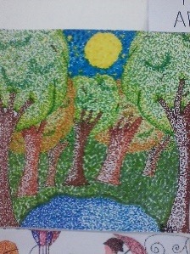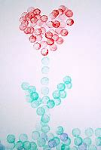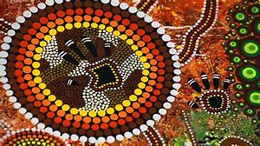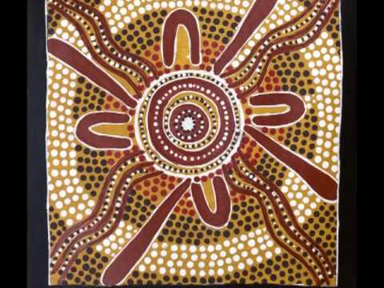
- Heather Galler Pattern landscape
Draw a landscape, split it into sections, add different patterns then colour. I usually use water colour pencils but pencil crayon or felts will do.
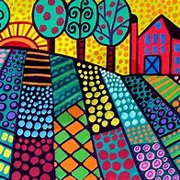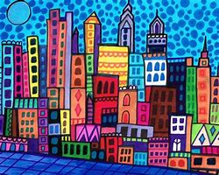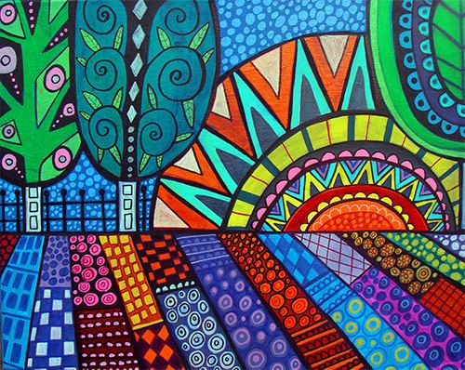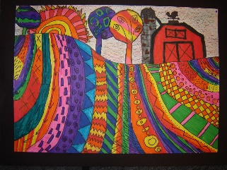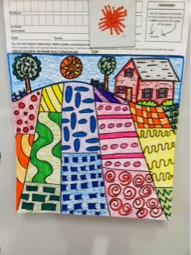

- Leonardo Da Vinci Invention
Leonardo came up with many inventions which he drew. He added notes about how it would work and how he could make it. What invention would you make? Draw it. Add notes about how it would work.
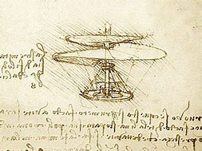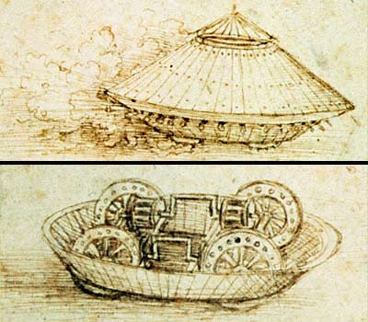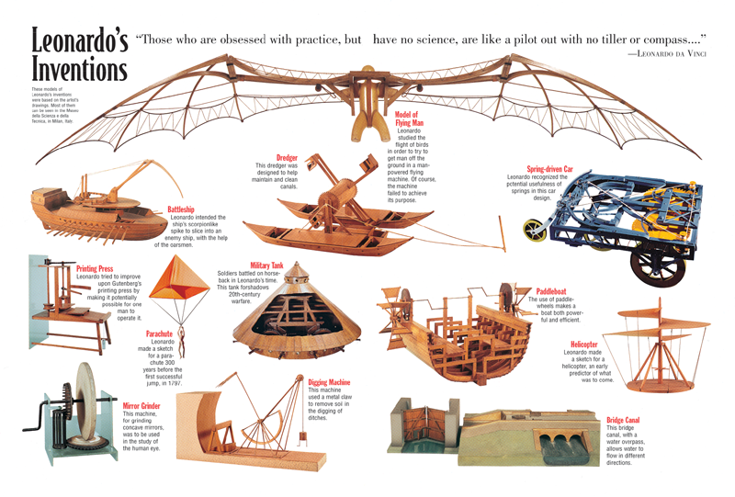
- Follow ‘Art for Kids hub’ on YouTube
There are lots of step by step fun videos to try. (If you find any other good websites or YouTube sites let me know!)

- Visit Gosketch.co.uk (Emma runs an art club at school on Thursdays) www.gosketchclub.com
There is a free online Zendoodle animal course and 75% off her ArtQuest course and Cartoon Studio Course. Lots of great ideas to keep you going.

- Take part in the Lego Challenge
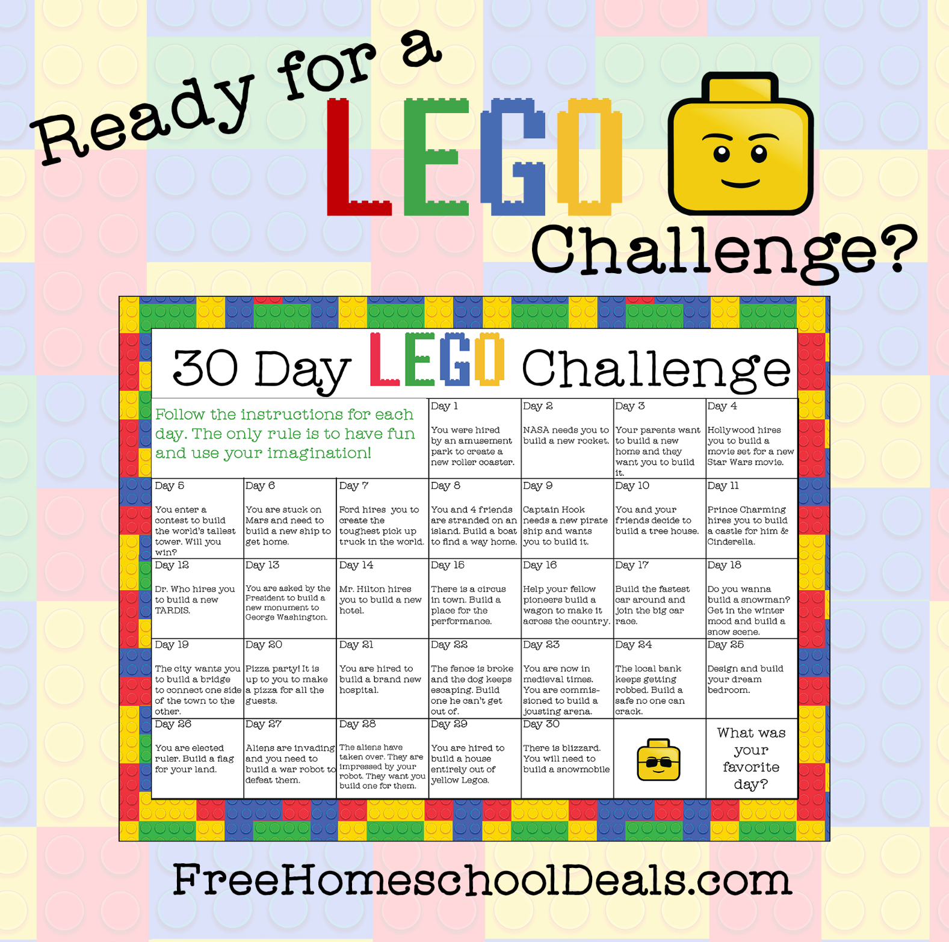

Create, colour, draw and doodle.
Draw what you see, feel, think and imagine.

