Art Ideas 2
Here are some further art ideas. Some of these will take a little longer than the previous suggestions and might need more equipment e.g. paint.
Surprise Animal Mouths
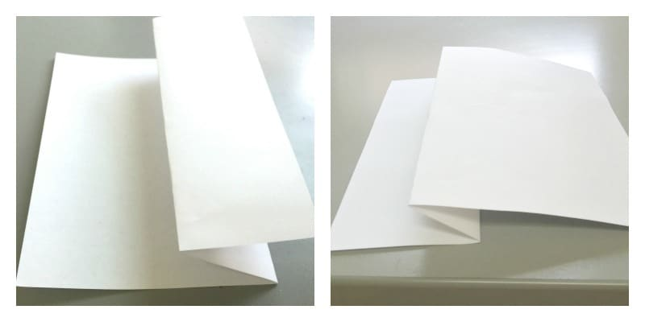
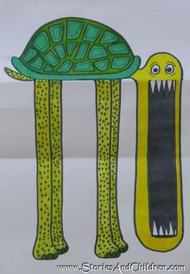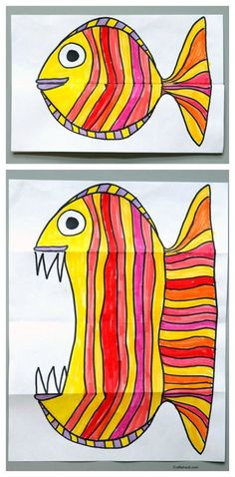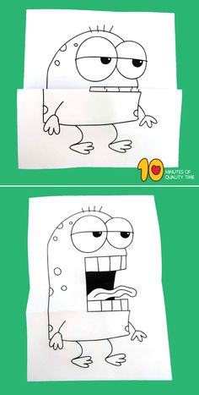
- Fold your piece of paper in half, widthways.
- Fold back one or both of the two edges opposite from the first fold.
(The fish one above has 3 folds, but the others here only have 2 folds.)
- Draw your sweet, gentle animal with pencil on the paper when folded, being careful where the folds are: you want to make sure the mouth looks good closed, but that it also will look terrifyingly fierce when you open up the paper. (TIP: drawing some sort of weird lips works well to hide the join.)
- Open your page up and draw in your giant, gaping mouth, complete with pointy teeth etc. Draw in the rest of the body on the rest of the paper, and add in any details such as: scales, lines, feathers, random hands, fins, fur, etc.
- Go round the main lines in sharpie (or black felt tip or push harder with your pencil to make it darker). Add colour.
- The next step is to spend some time making your animals talk and having fun! You could even record some as an animation.

- Drawing animals using your hand outline.
Check out the video to see how. www.youtube.com/watch?v=GdzfUog6oqk&app=desktop
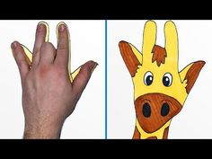
- Foreshortening
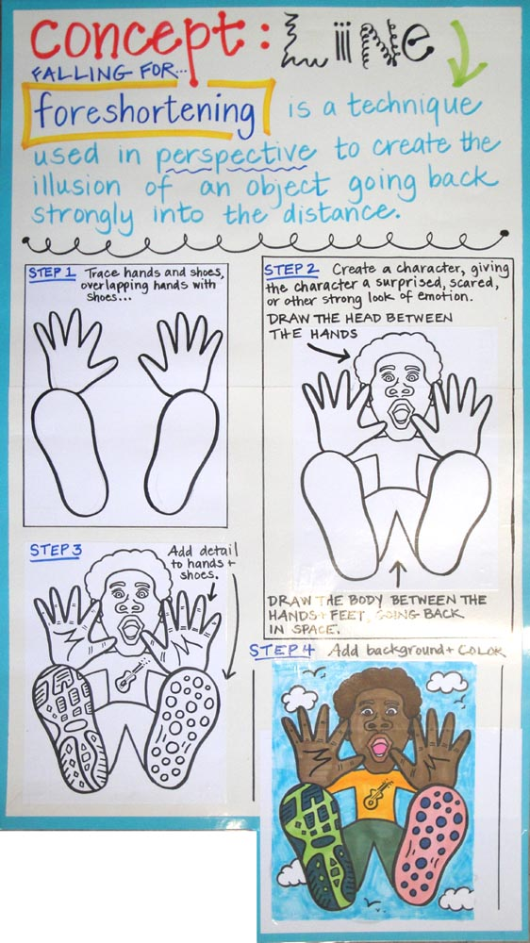

- Doodling on tin foil.
Cut out a piece of cardboard (e.g. cereal packet) and fold a piece of foil around it. I usually do double thickness. Tape it in place on the back. With a blunt pencil create your doodle. Colour in any parts you like with sharpies. Felt tips will do but they do smudge. You don’t have to colour it in though. You could stick your doodle foil in the middle of a piece of paper then continue your design onto the paper.
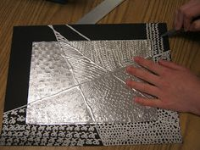
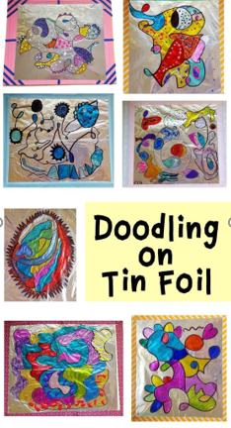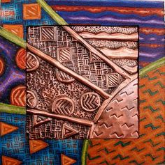

- Blow paint mini monsters
You’ll need some paint (water down appropriately) and a straw.
Put some paint on the page and then blow, blow, blow (turn the page to get different angles). Once dry you can add details e.g. eye, horns etc. You could use googly eyes if you have any.

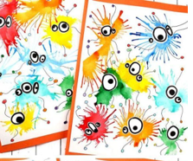

- Overlapping Cityscape
You could use colour or just monochrome (black/white)
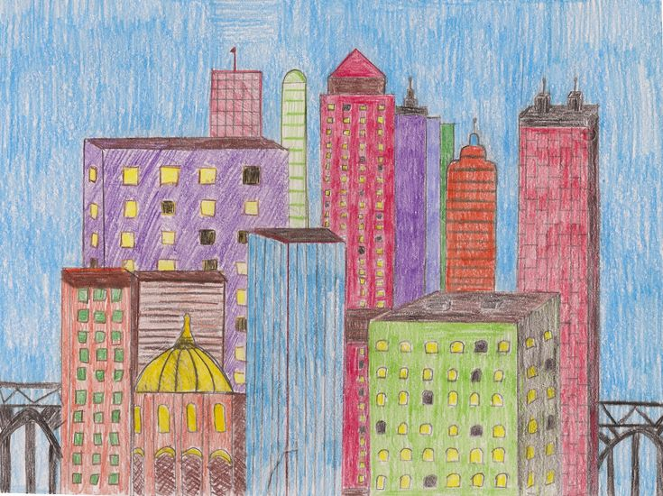
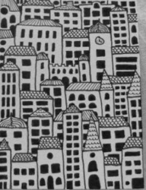
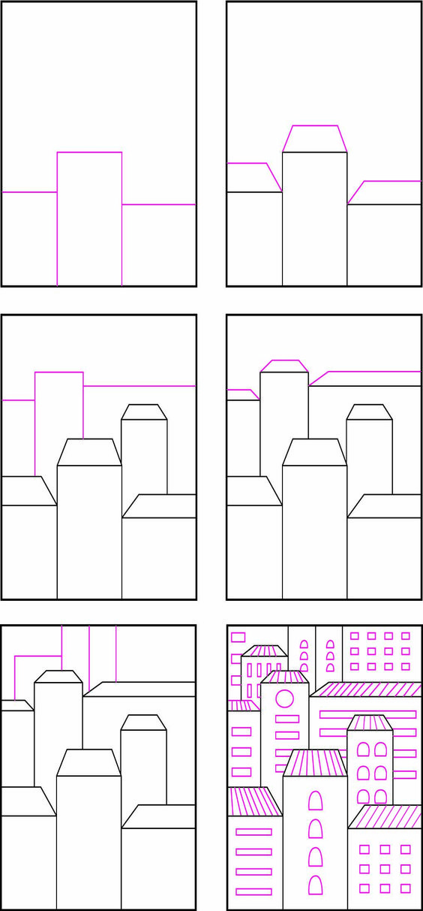

- Dot!
Create a dot out of coloured or black paper. Stick it on a blank piece. What could your dot be?
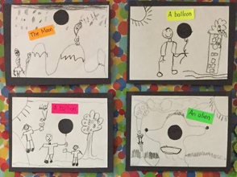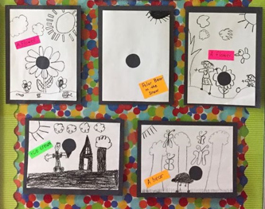
- Figurative ’Giacometti’ foil sculptures
Look at images of people doing sports or standing in different poses. You could take turns with someone and draw stick men to show the postures.
Take some foil and squeeze it into the body shape of the pose you want. (You can use pipe-cleaners to make the general body shape first then add foil over the top.) Use blue-tac or tape to secure it onto some paper. Put it out in the sun and look at the shadow created. Draw around the shadow and shade it in. You could even add different shadows are different times of the day.
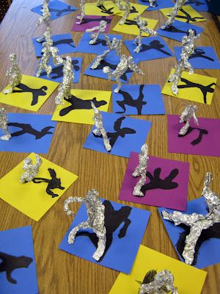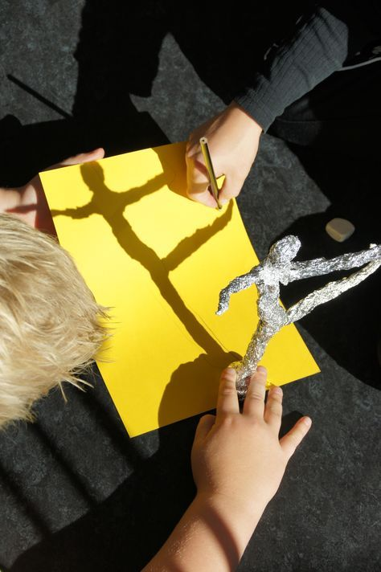

- One-Point Perspective landscapes
Follow the step by step pictures. For the desert one it is the same process, except the vanishing point is on the left of the horizon line rather than the centre. Remember as things get further away from you they look smaller.
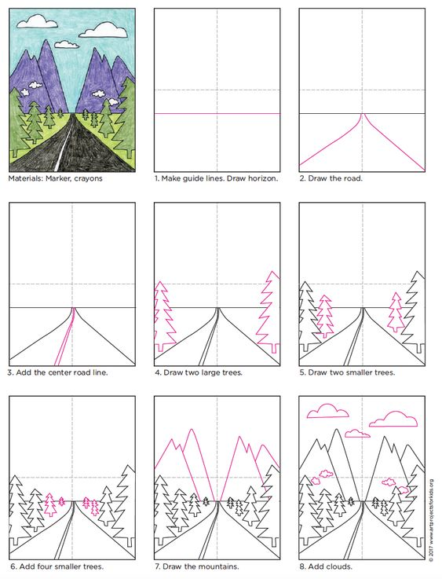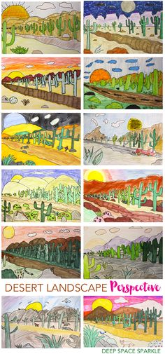

- Some more visual illusion ideas
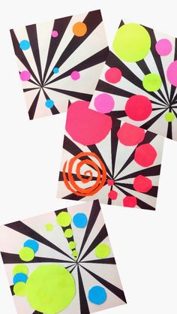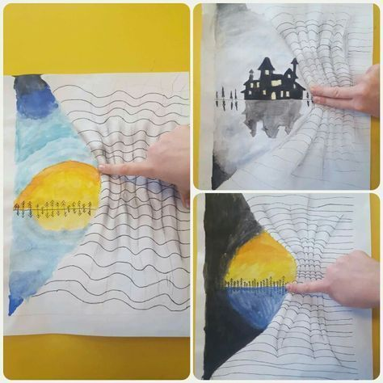
(Left) You will need two pieces of paper then same size to start (one black and one white). Draw a vanishing point on the black one and then lots of straight lines coming out from it to the edge. Cut them out and stick every other strip from a similarly placed vanishing point on the white paper. Add other bright coloured shapes to create an interesting design (composition). Smaller shapes will look like they are further away, larger ones closer so a good idea is to place the smaller shapes closer to the vanishing point.
(Right) On a Page draw a wiggly line from the top left corner to the bottom left corner curving into towards the centre like a scarf being pulled back. On the left add a landscape scene. On the right of the line draw horizontal wiggly lines from top to bottom. Add shading so it looks like there are folds. If you look at the picture, there is some shading on the edges of the down curve of each wiggle.

- Make and decorate paper aeroplanes (then see which one flies the furthest!)
Youtube – www.youtube.com/watch?time_continue=6&v=SpYS5WtvNvQ&feature=emb_logo
- Watch this free video about Claude Monet (one of Mrs Fraser’s favourite artists EVER). Create your own piece of art inspired by it.
Go to www.gettingtoknow.com or youtube.com/watch?v=3b668aY1Dgc (Apologies if the song gets stuck in your head!)

- Pick an everyday item. Trace round your object several times overlapping them in places. Use your knowledge of colour to neatly fill in the spaces. (Complementary / harmonious / natural / warm / cold) 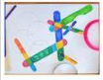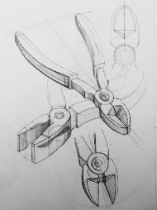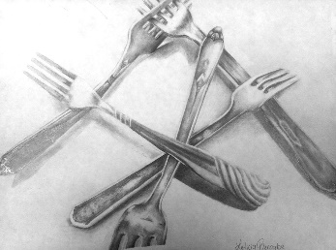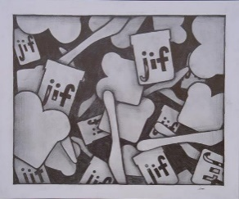
- Drawing madness
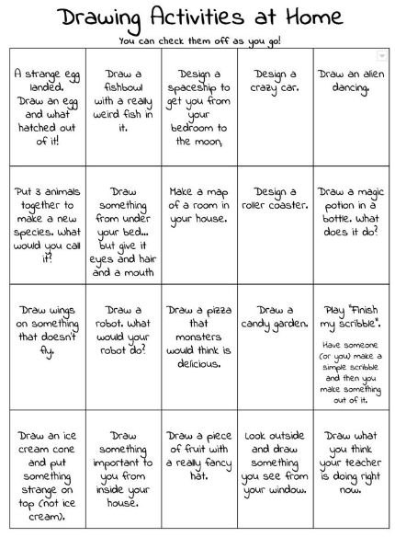

- Printing with Lego
Duplo works best but any Lego piece will do. You could create anything from robots to cityscapes. See what your imagination comes up with. (Paint will work if you don’t have ink printing pads.)

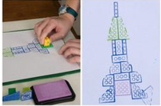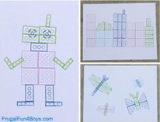

- Colourful Easter Bunnies (with cool glasses)
Draw a bunny (or use the template at the end of this document). Split it into sections and fill each with a different pattern. If you want to you could cut it out and stick it onto coloured or painted paper. Add some funky glasses too – you could add foil, sequins, feathers to them!

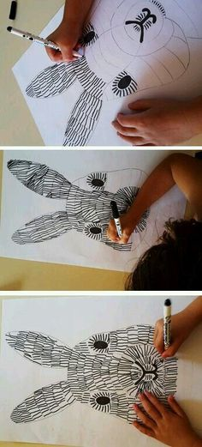
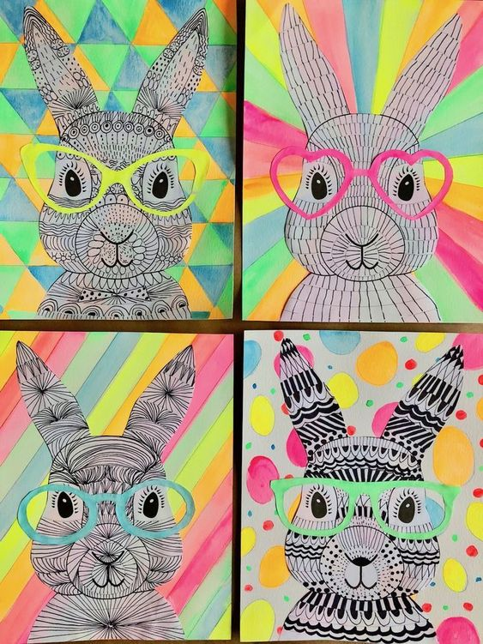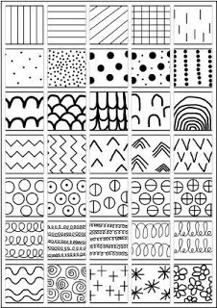

- Pirates Ahoy
A project for a few days. Paint a sunset/sunrise wash background half way down your page (lines of red, orange and yellow horizontally across the page in long, clean strokes). Paint a different piece of paper in blues. You could drop on some rock salt or lay a piece of cling film on it and leave it to dry to get some interesting patterns, or use a fork/stick etc to create patterns in the paint.
While it is drying create your pirate ship or galleon. Have a look at some ships on the internet or in books for inspiration.
Once the blue paper is dry, rip it into strips and layer it for the sea, remembering to add the hull of the ship half way through.
Stick it all down and add bright coloured sails.


