Art Ideas 3
Toy Photography – set up a picture using any toys you have. Here are some ideas to get you started.
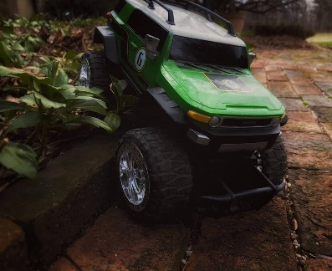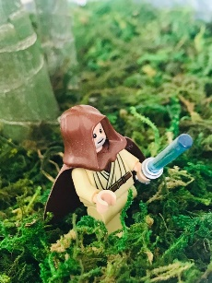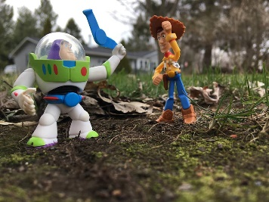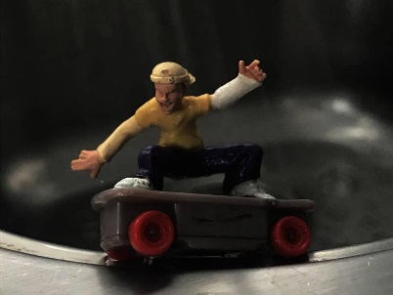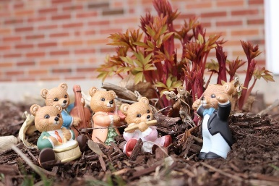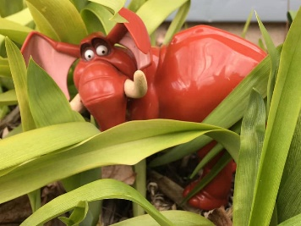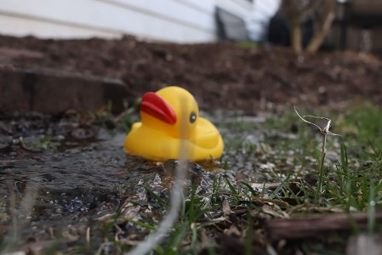

Magic Colouring: Watch the colours appear in front of your eyes. You’ll need some kitchen towel, a sharpie and felt-tips. Follow the full instructions here - https://www.youtube.com/watch?v=KX19xFfaRo8
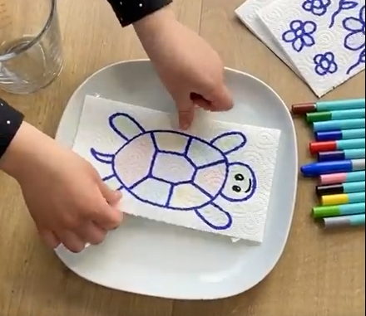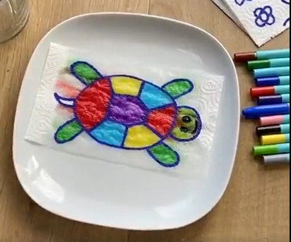

Colour Wheel Challenge: Using items from your house create a colour wheel. Can you find examples of the 3 primary colours and the 3 secondary colours?
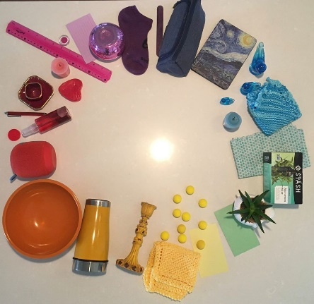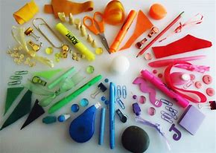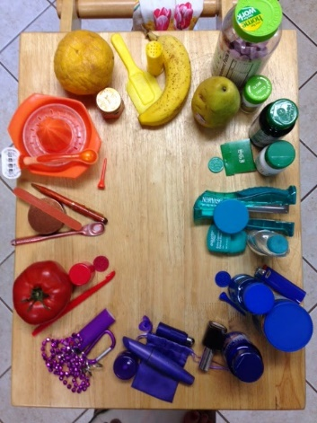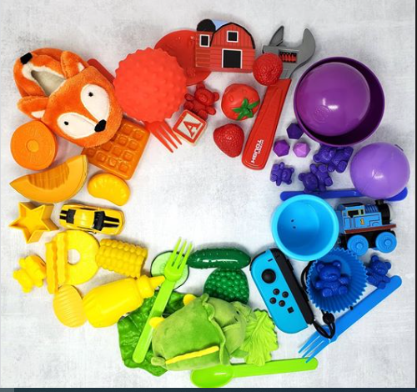

Toilet Roll Totem Pole: Research totem poles and collect ideas for your designs. You could use animals you can find in your garden as inspiration.
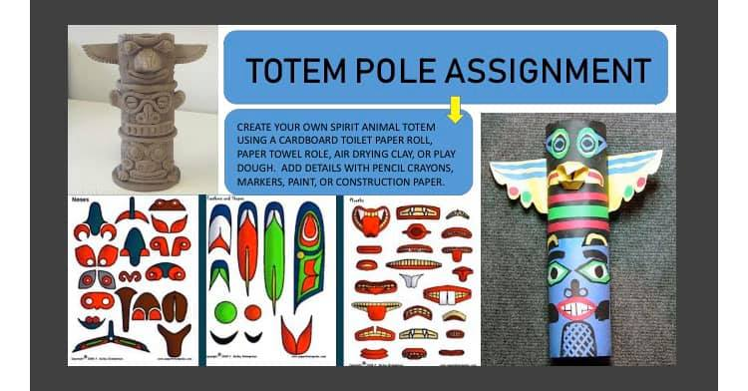

Alphabet Hunt: Can you find each letter of the alphabet in the environment around you?
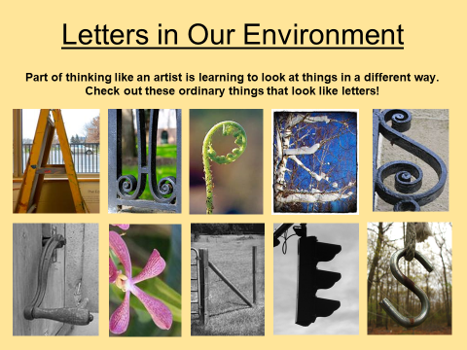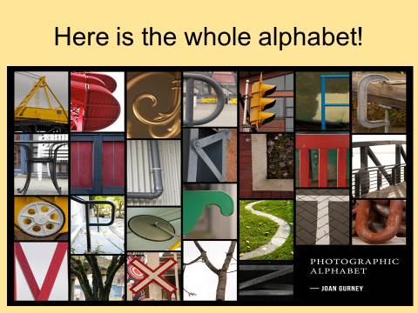

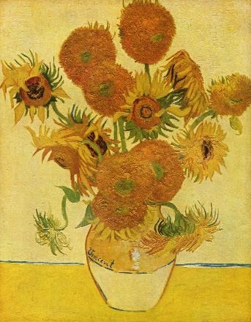
Create a vase of flowers: Complete the vases (or draw your own) and colour them in (You could do all three, just one or draw your own). What flowers can you add to them? You could use real flowers, sketch ones from your garden or use pictures of flowers from anywhere. You could even base your design on the famous ‘Sunflowers’ by Van Gogh.
(See the end of the document for a larger version.)
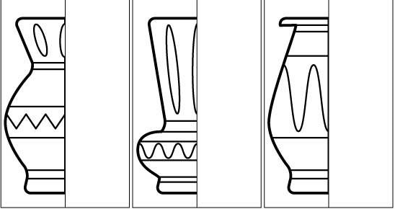

Painted Paper and foil birds: I love watching the birds in my garden so I decided to make one out of foil and painted paper. Follow the picture instructions here to make your own. It did take me quite a long time but it was fun (and sticky)!
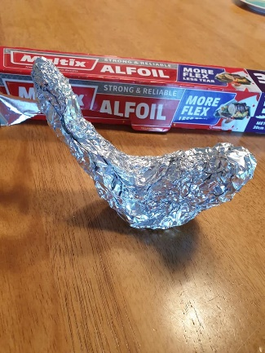
- Make a bird shape out of scrunched up paper then cover with foil.

- Tear up some coloured paper and glue it onto the bird shape
(use plenty of glue) then leave it to dry.
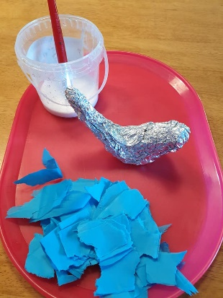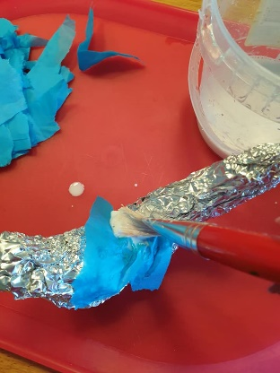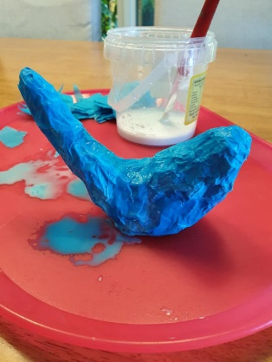

- Paint some paper with the colours you want for your bird. (I painted onto the blank backs of some envelopes I got through the post.) Leave these to dry then rip them into feather pieces. I chose to rip some long, some shorter and some really small feather shapes for around the neck.
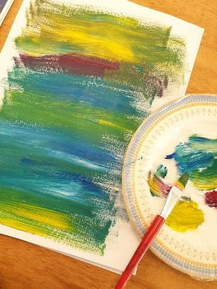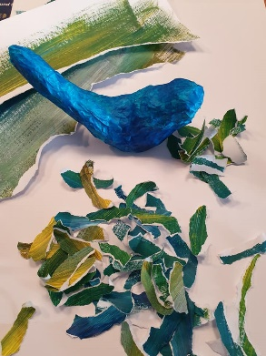
- Finally glue them onto your bird, overlapping them. Think about where the wings will go, angling the feathers outwards. Mine wouldn’t sit properly on the table as its tail was too short so I hung it up instead!
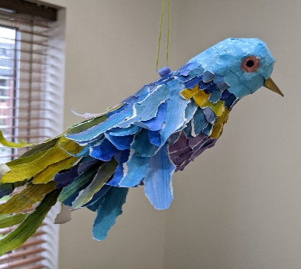
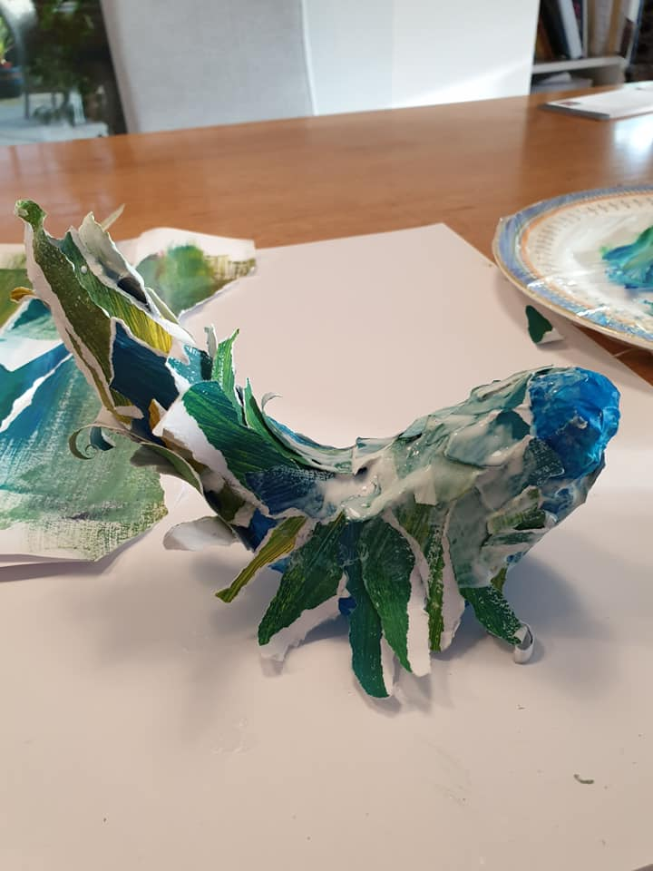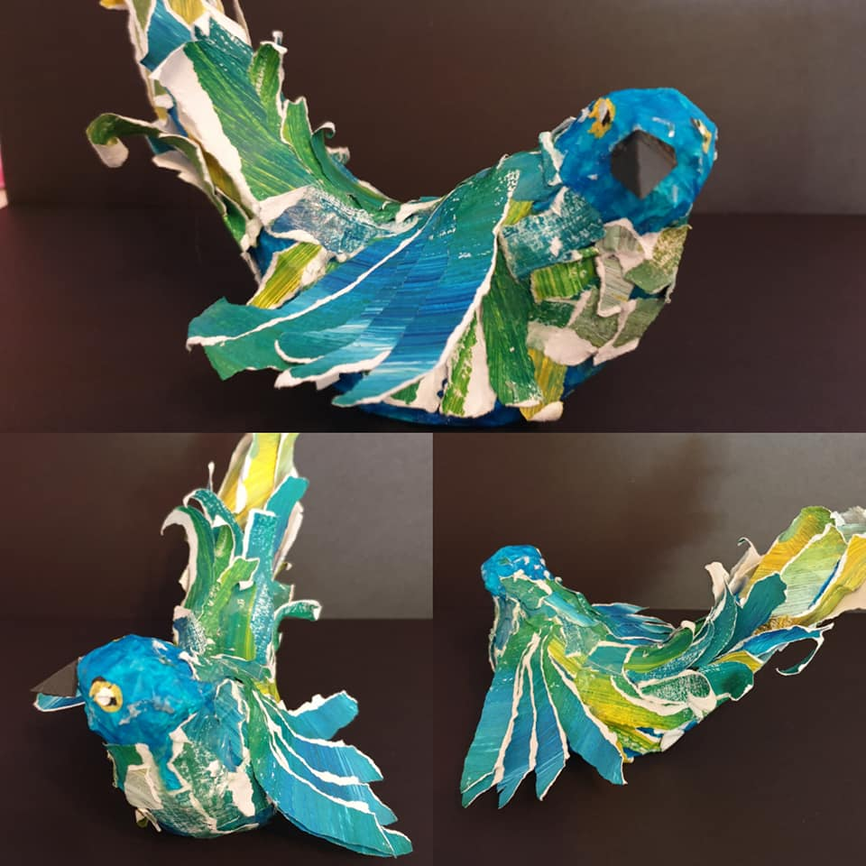
I had a go too. Here is the bird I made.

Card Board sculpture: Use any cardboard you have in your recycling bin. You could try to re-create your favourite food or a robot or anything.
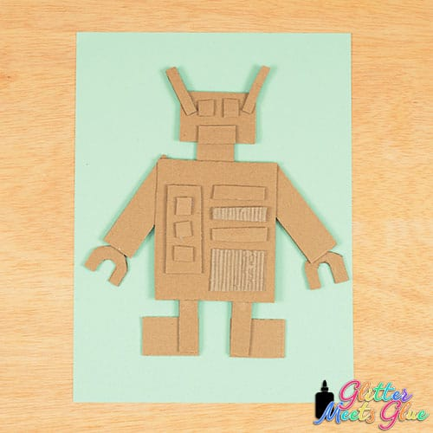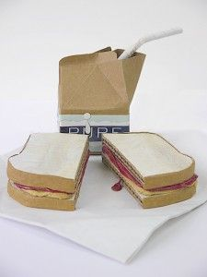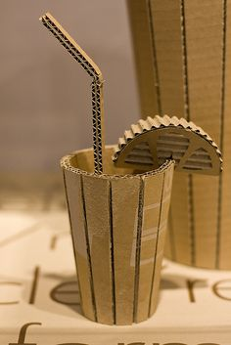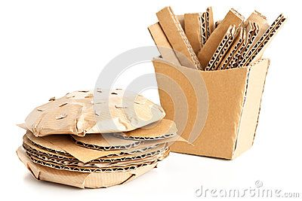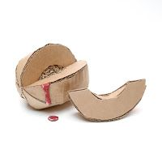

Hair Days: We are all going to come out of this with more ‘interesting’ hair-dos! Get a photo of yourself or draw yourself and add a zendoodle hair-do. You can go mad with colours too. Here are some already done.
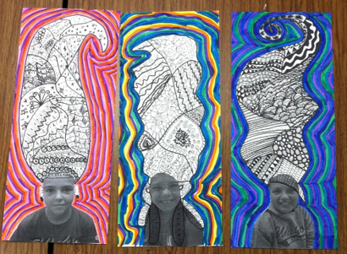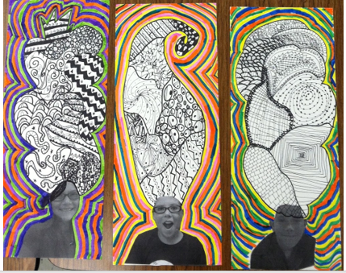

Homemade Scratch Drawings
Use crayons to builds up a waxy layer on a piece of paper or card. Go all over it with a black. Once it is all covered then scratch out a design using anything pointy (an unwound paperclip or cocktail stick works well). The best part is that if you do something you don’t like then you can colour over it and try again.
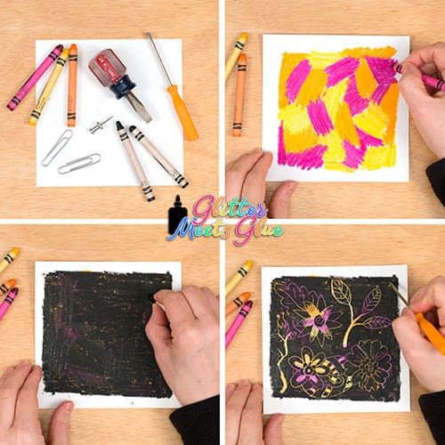

Isometric Drawings: Use the dots or triangular paper to create 3D pictures. Add shading to emphasise the 3D’ness. (Printable paper at the end of this document.)


