Key Question: Did World War Two affect every aspect of people’s lives in London?
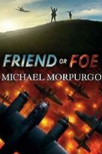  English: Our English lessons this term links to our study of World War Two. We will be discovering what life was like for an evacuee through the story Friend or Foe. This will be used to inspire writing such as diaries, letters and reports.  We will also be studying poems inspired by nature and written by Ted Hughes. | 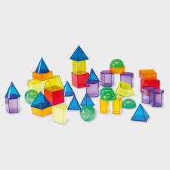  Maths: We will begin with place value and reading and writing numbers to 10,000,000. Children will learn to compare, order and round integers. They will also build on previous learning of negative numbers. This will be followed by recapping the 4 rules of number, before studying equivalent fractions as well as learning to add, subtract multiply and divide fractions and finding fraction of amounts. |   Science: Our first topic is Evolution and Inheritance. This includes studying fossils and how species have changed over time. We will look at how plants and animals have adapted to survive in their environments and will research two well-known scientists involved in this area of science: Charles Darwin and Mary Anning. We will also study how characteristics are passed from parents to offspring and that living things change over time.
History: We will be finding out about what life was like in Britain during WW2 – with a specific focus on the impact it had within Ruislip. We will learn about rationing, shelters, evacuation, coding, The Battle of Britain and how the war ended. We will place this knowledge in the context of a world history timeline and explore influences on the modern world. A visit to the RAF Museum and The Battle of Britain Bunker will enhance our understanding of the topic. | 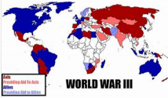  Geography: We will locate the Axis and Allied countries involved in WW2. Using atlases and technology we will discover where bombs were dropped in our local area. We will discover where children were evacuated to and how countries of the Commonwealth supported the war effort. | Art: We will study the artist L.S Lowry who is well-known for his landscapes and industrial drawings. We will research his style and recreate landscapes based on his works  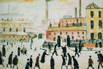  Design Technology: Having learnt about rationing in topic lessons, we will bake cookies using rationed ingredients and compare this to cookies baked using non-rationing ingredients.  Alongside our learning on WW2 shelters, we will design and build shelters.
  P.E: In PE this term, we will be developing our gymnastics and indoor athletics skills. We will work to improve our balance, agility and coordination.  In outdoor PE we will be taking part in a rotation of fitness, netball and dance. |   French: We will be learning the basic phonetics in the French language. Our main topics will focus on how we present ourselves to others and our family. |   PSHE: In PSHE, we will be revisiting and exploring the meaning of our school values, A TORCH. We will also be looking at how to be assertive, solving friendship problems and stereotypes.
  R.E: We are learning about the history and traditions of the Jewish faith. We will be studying The Passover, The 10 Commandments and Plagues of Egypt. Children will also recap the beliefs of Religions already studied such as Christianity, Hinduism and Skihism. We will learn about | Computing: We will learn about the importance of internet addresses and recognise how data is transferred across the internet. We will evaluate how sharing information online can help people to work together. We will learn about how we can work in three dimensions on a computer and how objects can be modified and combined. Eventually we will plan and create our own digital 3D model. |   Music: We will be learning to play the basic cords on the ukulele and understanding the history of the instrument. We will be using the correct techniques to play a range of songs. There will also be a link to our WW2 topic and the music of that time.
Trip suggestions:
RAF Hendon - https://www.rafmuseum.org.uk/ Museum of London Docklands - https://www.museumoflondon.org.uk/museum-london-docklands/permanent-galleries/docklands-war
Battle of Britain Bunker (Uxbridge) - http://battleofbritainbunker.co.uk/ Science Museum - https://www.sciencemuseum.org.uk/visit
National History Museum - https://www.nhm.ac.uk/
Imperial War Museum - https://www.iwm.org.uk/

