Key Question: How have Ancient Greek life and achievements influenced our British culture?
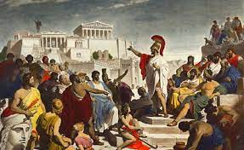  English: The bulk of our English lessons this term are based around our study of Ancient Greek Myths. These provide the subject for comprehension exercises and the prominent themes provide the basis for discussions and drama exercises. Our grammar work will focus on modal verbs, relative pronouns and the different forms of parenthesis. Please encourage your child to read as much as possible at home. | 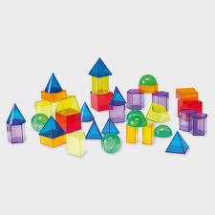  Maths: The main topics this term are addition and subtraction, multiplication and division and fractions. We will begin with a recap of place value in numbers up to one million, before looking at rounding, comparing and partitioning numbers. At home, any practical real life mathematical activity is valuable in supporting your child’s mathematical development. | 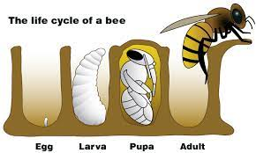  Science: We are exploring the lifecycles of plants and animals. We will learn about the lifecycles of different species, identifying similarities and differences. We will also look at how animals adapt to their environment over time. Finally, we consider the different stages of the human lifecycle.
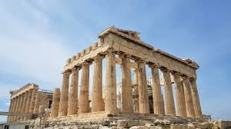  History: We will be finding out about the Ancient Greeks – how they lived and what they believed. We will place this knowledge in the context of a world history timeline and explore influences on the modern world. A visit to The British Museum would help to enhance your child’s learning in this area. |   Geography: We will locate Greece on European and world maps. Using atlases, we will find out about its physical features and place names. We go on to compare the climates of Greece and Great Britain. | 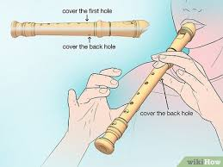  Music: We will be learning to play the recorder, using the correct technique, and reading from musical notation. Using our knowledge of the different notes, we will improvise and compose our own pieces of music. We will learn to play rhythmically and confidently as part of an ensemble.
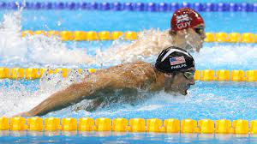  P.E: In PE this term, we will be developing our gymnastics, football and netball skills. We will also be completing our swimming lessons at Highgrove Pool. Any swimming your child can do in addition to these lessons will be of benefit. | 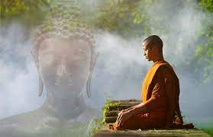  R.E: We are learning about the ways in which Hindus and Christians approach the idea of God. We will compare and contrast these approaches and discuss the meaning of Braham in the Hindu religion. | 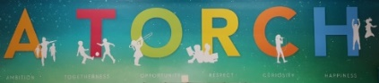  PSHE: In PSHE, we will be revisiting and exploring the meaning of our school values, A TORCH. We will also be looking at successful relationships and how to be a good friend. We will also consider our emotional needs and how we communicate them.
  French: We will be learning how to count to 20, use salutations, and discuss our pets in French. We will learn how to name and spell the days of the week, and the months of the year. | 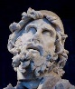  Art: We will create friezes depicting aspects of Greek life and attempt to recreate Caravaggio’s Medusa. Design Technology: We will be creating our own Greek Salad. We will consider safety and hygiene as well as the nutritional benefits of the ingredients. |   Computing: We develop understanding of computer systems and how information is transferred between devices. We discover how information is found on the World Wide Web, through learning how search engines work.

