Key Question: How have the Romans influenced our lives today?
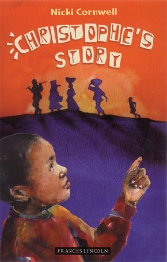  English: We are reading Christophe’s Story in our English lessons. It is the powerful and moving story of a refugee, his arrival in England, and his memories of his past in Africa. A good source for work on character and motivation, as well as giving insight into a contemporary issue. | 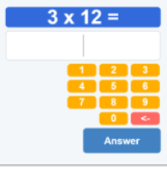  Maths: In Maths we are continuing the White Rose scheme, focusing initially on place value. We’ll also be completing lots of times tables practice, in preparation for the Times Table Check. This national test happens at the end of Year 4, and assesses whether children know all their tables to 12 x 12 ‘by heart’. | 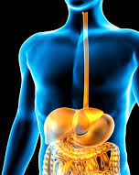  Science: This term we are learning about animals, including humans, and our first focus is on the process of digestion in humans. There are lots of opportunities to learn scientific words and find out about some amazing processes. Some may make us feel queasy!
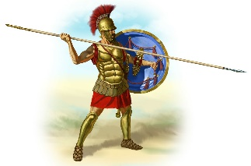  History: Last year we learnt about the Stone Age. Now we travel forward in time to the time of the Ancient Romans. We will have a special focus on the Romans as part of British history. | 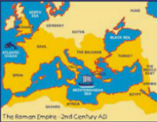  Geography: Linking to our History topic of the Romans, we will be looking at different maps, locating the Roman empire and its spread through their invasion. We will also be looking at their influence on the roads and infrastructure in the UK.  We will be studying Hadrian’s wall and its size and structure when it was built. | Music: We will be learning to play the glockenspiel this term. Lovely tuneful lessons for all.  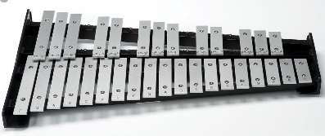
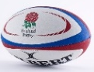      P.E: In PE we will begin with invasion games: netball, football and rugby. In indoor PE we will be focusing on gymnastics, including balancing, rolling and jumping. | 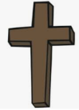    R.E: We will be looking deeper into Christianity and Islam. We will be looking at each religions ideas and beliefs on God. | 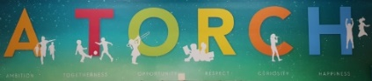  PSHE: In PSHE, we will be continuing to learn about our school values, A TORCH (Ambition, Togetherness, Opportunity, Respect, Curiosity and Happiness), British values and protected characteristics.
  French: We will be learning about the Olympics. We will find out about the history and origins of the Olympic games before moving onto reading, writing and pronouncing some sporting events in French. |   Computing: In Computing we will be looking a different networks and how they help us communicate in different ways. We will also be looking at different software programmes and their use for a specific purpose. | 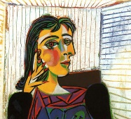  Art: We are starting a project on the early work of Picasso, with a focus on the human face. We will start by learning how to draw a naturalistic face, then become steadily more abstract or Cubist!

