Key Question: How did the arrival of the Empire Windrush change the way black people were treated in Britain?
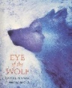  English: We will begin the Spring term by studying poems inspired by nature and written by Ted Hughes. We will learn about figurative language, imagery and the structure of poems.  We will then begin studying our new book: Eye of the Wolf by Daniel Pennac. We will learn about different climates and continents, which will be used to inspire a range of writing and our trip to Woburn. | 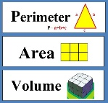  Maths: We will cover a range of topics including ratio, algebra and statistics. We will learn to convert between fractions, decimals and percentages. We will also recap previous learning of area and perimeter and then learn about volume. | 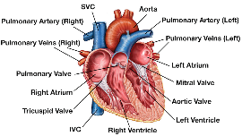  Science: Our new topic is Animals including Humans. We will learn about the human circulatory system. This will include describing the functions of the heart, blood vessels and blood. We will also learn about the function of the lungs in the respiratory system. We will also explore common blood disorders, which will help us to write an interview with a red blood cell.
History:  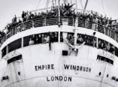  We will be studying The Empire Windrush. We will discover who the passengers were and why they decided to take the journey. We will look at the economic and cultural impact the Windrush generation had on Britain and their contribution to life in the UK. | 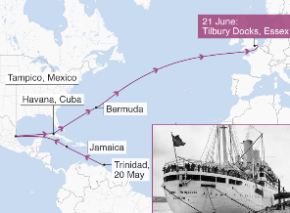  Geography: We will discover the journey the Empire Windrush took from the Caribbean to Britain and will compare a region of the UK with an area in the Caribbean. | 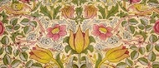  Art: We will learn about the work of Georges Seurat and William Morris. We will create river landscape paintings in the style of Seurat using pointillism. We will also replicate the William Morris technique of repeating patterns.  Design Technology: In DT, we will design, create and evaluate phone covers. We will learn how to create a running stitch and blanket stitch in order to create our design. When complete, we will evaluate our work. We will also be cooking a Caribbean inspired, three course meal.
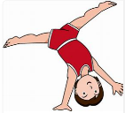  P.E: In PE this term, we will be learning the skills and rules of dodgeball. We will work on developing our coordination and agility.  We will be taking part in Dance lessons this half term where we will learn the Charleston. | 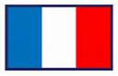  French: Our topic is ‘At School’, where children how to pronounce school subjects and school equipment. They will also continue to learn to read and write sentence in French. | 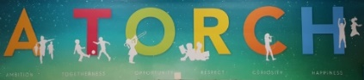  PSHE: In PSHE, we will be revisiting and exploring the meaning of our school values, A TORCH. We will also be looking at how to be assertive, solving friendship problems and stereotypes.
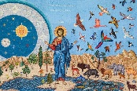  R.E: We will learn about the creation stories of the main religions in our community. We will then compare the creation stories to those of Ancient Civilisations, which will link to previous learning. | 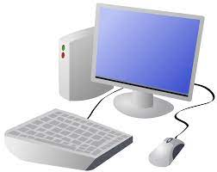  Computing: We will identify what makes a good web page and use this information to design and evaluate our own website. During the lessons, we will pay specific attention to copyright and fair use of media, the aesthetics of the site, and navigation paths.  In the Spring 2nd term, we will learn about spreadsheets. We will be taught the importance of formatting data to support calculations, while also being introduced to formulas and will begin to understand how they can be used to produce calculated data. | 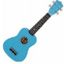  Music: We will continue to learn the ukulele. The children will have learnt at least 5 chords (including minor and major chords) and will begin to change more fluidly between them to play a range of songs using a desired strumming technique. The children will also notate their own pieces of music by playing around with the notes and chords they have practised, to create sounds that blend well together.
Trip suggestions: Science Museum - https://www.sciencemuseum.org.uk/visit National History Museum - https://www.nhm.ac.uk/ National Gallery - https://www.nationalgallery.org.uk/

