Key question: The UK past and present - How has the landscape changed over time?
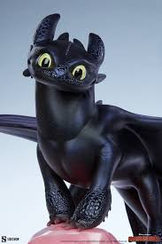  English: Most of our English lessons this term are based around our study of the novel How to Train Your Dragon. This provides the subject for comprehension exercises and the prominent themes provide the basis for discussions and drama exercises. Our grammar work reinforces the elements covered in Term 1 and explores cohesion and the use of suffixes and prefixes. | 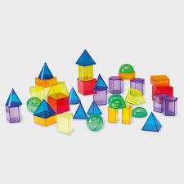  Maths: We are starting this term learning new methods for long multiplication and division. We will also continue our learning on fractions, decimals and percentages. We will learn to compare and add fractions and decimals and calculate percentages. We will then explore relationships between them and calculate some equivalencies. |   Science: We are exploring Materials. We will learn about the origins, properties and uses of materials. We will also look at changes to the state of materials and ask whether they are reversible or irreversible. Many cookery activities you can undertake at home with your child clearly illustrate these concepts.
  History: We will explore how life has changed in the UK over time. As part of this we will order a number of significant events, movements and dates on a timeline. using dates accurately.  We will also Identify and note connections, contrasts and trends over time in the everyday lives of people. | Geography: We aim to understand and identify different types in the UK land use and  Know about the key features of Human Geography. This will help us identify and describe human and physical features of modern UK. We will describe how changes have affected our environment. | 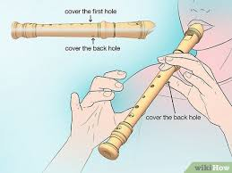  Music: We will continue playing the recorder, using the correct technique, and reading from musical notation. Using our knowledge of the different notes, we will improvise and compose our own pieces of music. We will learn to play rhythmically and confidently as part of an ensemble.
  P.E: In PE this term, we will be developing our knowledge and skills in the following areas:  Dodgeball  Dance  Outdoor and Adventurous Activities. | R.E: We will be exploring the main teachings of Jesus Christ outlined in the new testament including loving God, loving thy neighbour and forgiveness. We will also be learning about inspirational people, including, Martin Luther King, Mahatma Gandhi and Mother Teresa. |   PSHE: We will be focussing on keeping safe in a variety of ways. This includes healthy/beneficial lifestyle choices, attitudes to risk-taking, and correctly identifying and responding to bullying.
  French: We will be learning the vocabulary and language structures required to order a range of foods and drinks at a French café. Our second unit will be learning how to describe a range of weather conditions in French. |   Art: We will develop our painting and drawing abilities, starting with sketching and drawing dragon eyes in a range of media.  Design Technology: We will be  working on our sewing skills to  design and make a soft toy. |   Computing:. We will be learning about video editing and flat file databases. We will select, use, and combine a variety of software on a range of digital devices to create a range of programs, systems, and content that accomplish given goals, including collecting, analysing, evaluating, and presenting data.

