Key Question: Why is the Kingdom of Benin so significant?
  English: We are starting this half term by reading an ebook called ‘Where would you like to live?’ It is a wonderful book where we will discover more about our world in an interactive way! We will also study poetry, playing with words and will also become word detectives! | 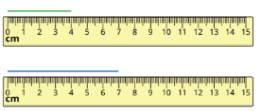  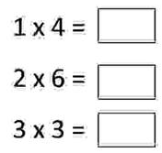  Maths: In Maths, we are continuing to follow the White Rose Scheme. We will carry on focusing on Multiplication and Division before moving onto Measurement; Length and Perimeter, Fractions and Mass and Capacity. | 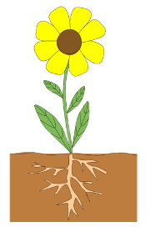  Science: This term we are learning about Plants and Light. We will be looking at the functions and parts of a flowering plant and investigate plant nutrition. We will take part in lots of multi-sensory investigations to promote our scientific minds!
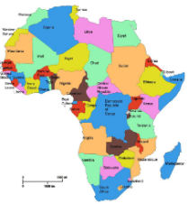  History: During this term we are working towards answering our Key Question: Why is the Kingdom of Benin so significant? We will explore the Kingdom of Benin, learn about their leaders and understand their trade networks with the rest of the world. | 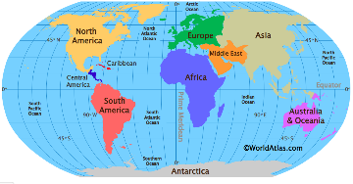  Geography: We will be identifying the continents and oceans of our world. We will look at identifying key cities and locations, understanding terms such as: equator and hemisphere. Maps, compasses and globes will help us to compare the location of such places. | 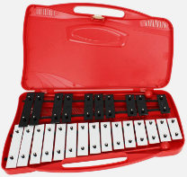  Music: We will be learning to play a new musical instrument; the Glockenspiel. We will become familiar with some of the notes and learn to play a simple tune, exploring ways to compose and play our own tune.
  P.E: In PE this half term, we will be covering Dance, Handball and Para Sports. The children will develop their counting and rhythm, be creative and find out more about using dance to respond to stimuli and various types of music. |   R.E: During this term, the children will be exploring the range of beliefs, symbols and actions for many different religions, including focussing on their importance. | 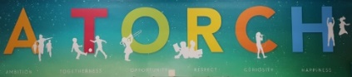  PSHE: In PSHE, we will be continuing to learn about our school values, A TORCH. We will see how these add to our community and support our learning in class.
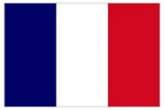  French: This term we are continuing to follow the Language Angels programme, teaching the children Animals and fruits. The children will learn 10 fruit nouns in their singular form. They will use indefinite articles, ‘une’ and ‘un’. They will also learn ‘les’ and names of Animals. | 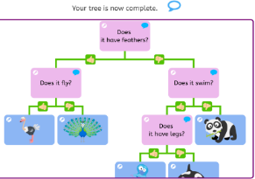  Computing: This term we will be focussing on Desktop Publishing and Branching Databases. During these units the children will create their own branching database and develop their digital skills when using digital publishing software. | 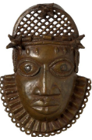  Art: We will begin our Art journey by focussing on an artist called Esther Mahlangu where we will explore her masterpieces and recreate these ourselves. We will also look at Benin Bronzes which is linked to our Topic lesson.

