Key Question: How has Ruislip Lido changed over time?
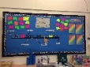  English: We are starting this half term learning about some short stories from fantasy/woodland worlds as well as poems with patterned and predictable structures.  We will develop our understanding of setting descriptions, story openers and predict what will happen in different stories. We will be following the Little Wandle scheme of learning for Phonics. | 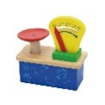  Maths: We will use the White Rose scheme of work to focus on number and place value. We will be continuing to add and subtract numbers. The children will also be looking at measuring height, length and mass. We will be using a range of abstract and concrete methods to support the children’s learning in these areas. We will be continuing to deepen understanding by looking at reasoning problems. | 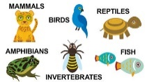  Science: We are learning about identifying and naming a variety of animals including  fish, amphibians, reptiles, birds and mammals. We will be looking at their characteristics and the group they belong to.  We will be looking at plants, trees and naming them too!
History: We are learning all about Ruislip Lido and the differences between the Lido in the past and today. We will discuss why the Lido has been a very important place for Ruislip for over 200 years.  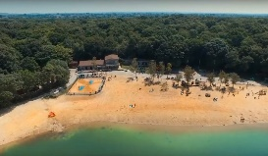  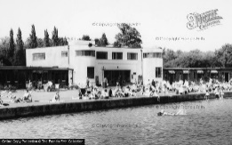 | 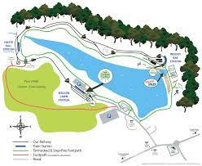  Geography: will be creating maps of real (The Lido) and imaginary places and will create keys for symbols on our maps. We will discuss and identify human and physical geography features of Ruislip Lido.  We will be visiting Ruislip Lido and Woods to help with our learning. | 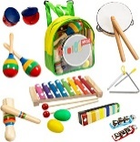  Music: Music: We will be exploring different types of music, such as: Blues, Baroque, Latin, Bhangra, Folk and Funk. This is following our Charanga scheme of music.
P.E: In PE this half term, we will be developing our dance skills and will be performing to our friends!  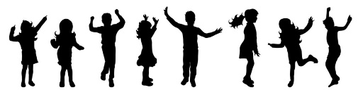 |   R.E: We will be learning about Christianity and how the people celebrate Easter. We will be learning about different special days leading up to Easter. |   PSHE: In PSHE, we will be focusing on keeping healthy and why we need to keep healthy as well as growing and changing.
  Computing: We will be exploring how to collect and interpret data. We will complete lots of different activities surrounding these topics. | Art:  Taught in Spring 1 | 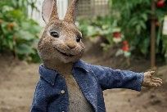  Design Technology: What would you make for Peter Rabbit on MasterChef? We will be choosing the right tools to peel, grate and chop, we will design and make a healthy dish. •

