Key Questions: What makes a great polar explorer?
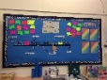  English: Throughout the Spring term, we will be continuing to focus on handwriting, reading and comprehension skills, as well as grammar and punctuation. We will be looking and extending our sentences using conjunctions and adjectives. We will continue to develop sentence construction using: capital letters, finger spaces, full stops and quality vocabulary. We will be writing a range of texts for different purposes such as: non-fiction writing, letters and postcards. We will be following the Little Wandle scheme of learning for Phonics. | 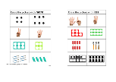  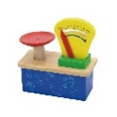  Maths: We will use the White Rose scheme of work to focus on number and place value. We will be continuing to add and subtract numbers. The children will also be looking at measuring height, length and mass. We will be using a range of abstract and concrete methods to support the children’s learning in these areas. We will be continuing to deepen understanding by looking at reasoning problems. | 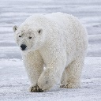  Science: We are learning about different polar region animals, looking at labelling their body structures and learning about adaptations and their eating habits. We will continue to complete various scientific experiments to support their learning in Science.
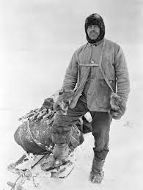  History: We are learning about the famous explorer Robert Falcon Scott. We will be thinking of questions about his expedition, looking at historical sources and comparing his journey to other explorers. | 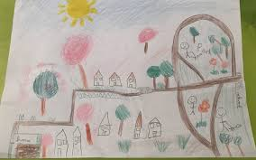  Geography: We will be looking at world maps, globes and atlases to locate the polar regions. We will be comparing the polar regions to Ruislip Manor. | 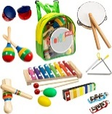  Music: We will be exploring different types of music, such as: Blues, Baroque, Latin, Bhangra, Folk and Funk. This is following our Charanga scheme of music.
P.E: In PE this term, we will be developing our  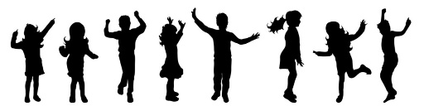  sending and receiving skills and playing target games. | R.E: We will be learning about Christianity and how the Bible is important to Christians. We will be learning about different parables. The children will be thinking about the meanings and teachings of the stories.  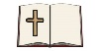 |   PSHE: In PSHE, following the scarf scheme of work, we will be focusing on valuing differences and being our best self by being healthy.
Computing: We will be following our computing scheme and learning about using a keyboard.  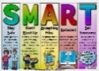  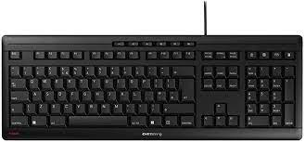 | 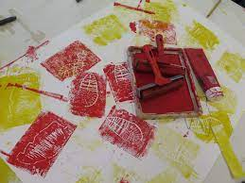  Art: In Art we will look at different ways to use paint and how to mix primary and secondary colours to recreate a painting. We will be focusing on printmaking too. | Design Technology:  Taught in Spring 2

