Key Question: Who is my Favourite Character?
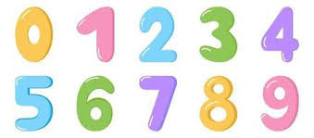  Maths:. We will be enjoying lots of songs and practical activities both inside and outside. This half term we are continuing to develop an understanding of early number bonds and will be focussing on the composition of 4,5,6,7 and 8, night and day and length and height. | Communication and Language: We will be starting this term with our topic ‘Who is my favourite character? We will be exploring traditional tales with a focus on The Three Billy Goats Gruff, Goldilocks and the Three Bears and The Three Little Pigs. The stories also give the children opportunities to create maps, talk about changes, making choices and consequences of not making the right choice. |  |   Literacy: This half term we will be looking at speech bubbles and non-fiction writing. There will be an opportunity to make porridge and write about how it was made. We will continue to focus on correct letter formation and introduce basic grammar features in sentences.
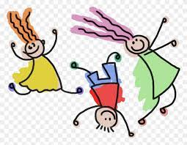  Physical Development: This half term we will continue to have Funky fingers activities set up daily to strengthen their fine motor skills. We will continue to provide lots of opportunities for the development of gross motor skills (eg bikes, balls, balancing etc). | Personal Social and Emotional Dev:  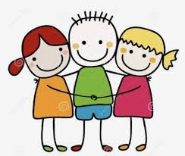  This term we will focus on allowing the children to see themselves as a valuable individual and recognise their talents. We will also focus on beginning to express their feelings and consider the feelings of others and develop problem solving strategies. |  | Understanding the World: This half term we will be learning about Chinese New Year and how it is celebrated. We will also compare and contrast characters from stories and explore people who help us in our daily lives.  
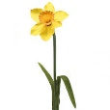  Expressive Arts and Design: This half term we will begin to draw with detail (bodies with sausage limbs and additional features). There will be opportunities to draw things they observe eg a flower. They will have opportunities to explore different ways of joining materials together and create collaboratively. |  | Phonics: We will be continuing our journey with phonics and move into phase 3. We will be introducing 4 new sounds each week which include digraphs and trigraphs. Children will read simple sentences aloud that are consistent with their phonic knowledge, including some common exception words (tricky words)  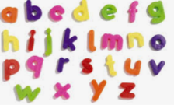
Lady Bankes Primary School - Curriculum Newsletter Spring 1
Reception

