Key Question: How did hunter-gatherers survive in the Prehistoric period?
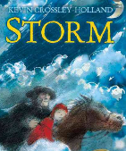  English: We are starting this half term by reading a book called ‘Storm’. It is a brilliant meshing of history and imagination. We will study the plot and main characters, and see if we can answer text related questions. | 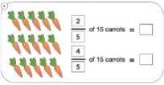  Maths: In Maths we are continuing the White Rose scheme, focusing initially on Place Value.  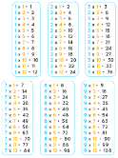  We will then move onto exploring Addition, Subtraction, Multiplication and Division with a focus on learning our times tables. | 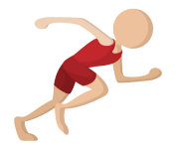  Science: This term we are learning about Animals including Humans. We will take part in lots of multi-sensory investigations that will teach the children about healthy eating and exercise.
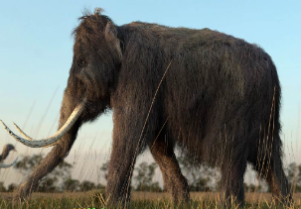  History: We are looking at how people lived in the Stone Age. We will consider the homes they built and the tools they used. We will also look at how communities changed and moved over time. | 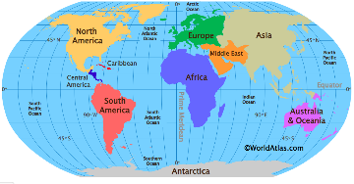  Geography: We will be identifying where the continents, oceans, equator, Northern, Southern hemisphere, Arctic and Antarctic circles are located. We will also understand geographical similarities and differences of human and physical geography of a region. | 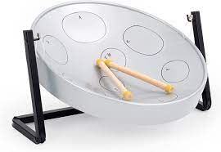  Music: We will be teaching children about the beat, rhythm and pitch of music during our Steel Pan lessons. They will also be shown ways of producing their own simple tunes.
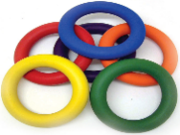  P.E: In PE this term, we will be developing our PE fundamentals, Gymnastics, and Indoor Athletics skills. |   R.E: We are learning about a variety of different religions and their beliefs. We will understand stories and miracles from religious texts. | 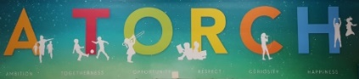  PSHE: In PSHE, we will be continuing to learn about our school values, A TORCH. We will see how these add to our community and support our learning in class.
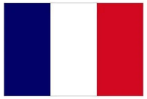  French: We will be introducing all of the children to our Language Angels programme. We will be able to speak in short, simple sentences, as well as read, listen and understand phrases. |   Computing: Throughout this term we will be teaching the children how to use technology safely, respectfully and responsibly and to understand the benefits of using the World Wide Web and the opportunities it offers for communication and collaboration. We will also explore the world of animation and attempt to create our own! | 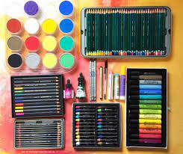  Art: Children will improve their mastery of art and design techniques – drawing and painting with a range of materials (pencil, pastels, charcoal), threading, shaping and moulding clay.

