Key Question: What do we celebrate?
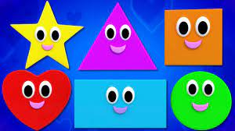  Maths: We will be continuing to build on our understanding of number and comparing quantities up to 5 in different contexts, recognising when one quantity is greater than, less than or the same as the other quantity. In this half term we will also learn to name, use and recognise the properties of shapes and use these shapes to create and continue repeating patterns. | 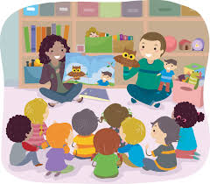  Communication and Language: This half term we will be learning about different celebrations where your child will be encouraged to share any of their personal experiences with the rest of the class. Your child will be learning lots of new vocabulary and will be encouraged to use this vocabulary in their play. |  | 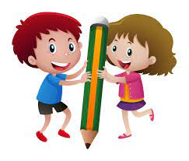  Literacy: This half term we will be exploring books relating to our topic of celebrations including The Toy’s Party and You Must Bring a Hat. We will be enjoying many practical activities related to the topic and your child will focus on learning and using new vocabulary and mark making.
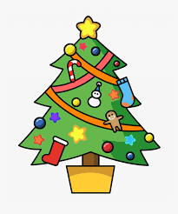  Physical Development: This half term we will continue to develop children’s physical development a range of activities both inside and outside. We will also be learning the dances for our Christmas show ready to perform to an audience. |   Personal Social and Emotional Development: This term we will be focusing on how to express our feelings appropriately and to consider the feelings of others. This term we will be working towards simple goals and thinking about being able to wait for what they want. |  |   Understanding the World: This half term we are exploring our celebrations topic with a range of activities including diva thumb pots, making Christmas cards and creating firework pictures.
Expressive Arts and Design: This half term children will be able practising and performing our Christmas show and will be enjoying a wide range of topic related activities.  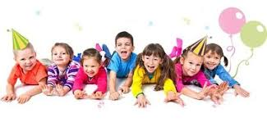 |  | 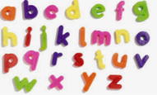  Phonics: This half term we will continuing to follow the Little Wandle scheme. We will focus on saying and recognising a sound for each letter in the alphabet and practise correct letter formation. We will start to use this knowledge to read simple words by sound blending.
Lady Bankes Primary School
Curriculum Newsletter Autumn 2
Reception

