Key Question: How am I changing?
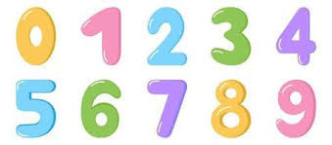  Maths: We will begin to have an understanding of number to 10, including how to subitise (recognise quantities without counting) to 5. We will be learning to count beyond 20, beginning to recognise the pattern of the counting system, making sure that we count accurately and with meaning. We will be enjoying lots of songs and practical activities both inside and outside. | Communication and Language: We will be starting this term with our topic about nursery rhymes where your child will have the chance to explore and perform songs and rhymes with the class. We will then focus on our ‘All About Me’ topic where we will encourage your child to share information about themselves. We will be supporting your child to speak using full sentences and to listen and participate in shared story times. |  |   Literacy: As well as learning and performing different nursery rhymes we will also be sharing some familiar stories where the children will be encouraged to respond to questions and listen carefully. We will be practising to hold our pencils correctly, write our names and learn correct formation of letters.
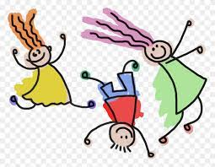  Physical Development: This half term we will have Funky fingers activities set up daily for fine motor skills and we will be providing lots of opportunities for the development of gross motor skills (eg trikes, balls, balancing etc). | 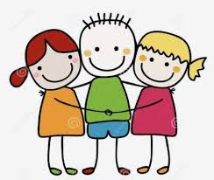  Personal Social and Emotional Development: This term we will be concentrating on settling into our new class, building relationships, dealing with conflict and learning the school rules. |  | 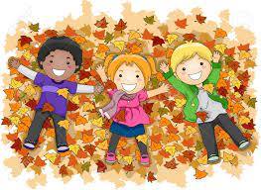  Understanding the World: This half term we will be exploring out topic of ‘All about Me’. We will be comparing similarities and differences and exploring the world around us, including going on an Autumn walk and exploring toys from the past.
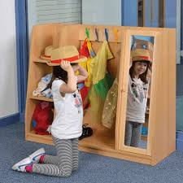  Expressive Arts and Design: This half term children will be able to use the different resources in the creative station. They will also have an opportunity to make an observational drawing of a flower and to create a self-portrait. Exploring our role play area is a focus for this half term where the children can become immersed in their own imaginative play. |  | Phonics: We will be starting to learn phonics this half term following the Little Wandle scheme. We will be learning the names and sounds of the letters and practising how they blend together for our reading and writing.  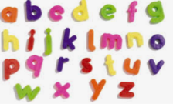
Lady Bankes Primary School - Curriculum Newsletter Autumn 1
Reception

