Autumn 1: Key Question: Did my family play with the same toys I do in the past?
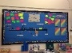  English: Throughout Autumn term, we will be focusing on handwriting, reading and comprehension skills, as well as grammar and punctuation. The development of quality vocabulary and learning how to construct a sentence, using a capital letter, finger spaces and a full stop will be the key focus. This will extend onto using a range of conjunctions within sentences and beginning to use adjectives.  We will be following the Little Wandle scheme  of learning for Phonics. | Maths: We will use the White Rose scheme of work to focus on number and place value. We will be learning to count, read and write to and across 100, forwards and backwards, beginning with 0 or any given number.  We will use a variety of practical objects to identify, sort and represent numbers to gain a deep understanding of number composition.  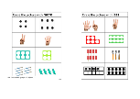  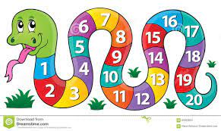 | 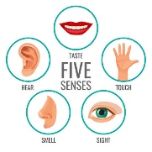  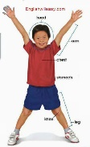  Science: We are learning all about the human body identifying, labelling, drawing and naming the basic parts of the body. We will say which part of the body is associated with each sense. Throughout the year we will be observing the different seasons too!
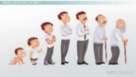  History: We are learning all about describing similarities and differences between life during a time in the past and life today, creating timelines appropriate to the children, using a wide range of vocabulary for everyday historical terms and asking questions about the past surrounding toys. | Geography: We will be asking questions about the local area and drawing maps of real life and made up places through cross-curricular activities.  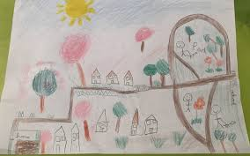 | 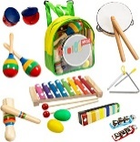  Music: We will be exploring the differences between pulse, rhythm and pitch and learn how to rap in its original form. This is following our Charanga scheme of music.
P.E: In PE this term, we will be developing our  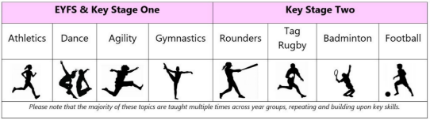  running, jumping, throwing, catching, balance and agility skills. | 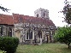  R.E: We will be learning about Christianity and how Christians show that they belong to a faith and what it means to belong. We will look at the importance of baptism, God, the bible being a special book for Christians. As well as, visiting churches in the local area.  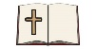 |   PSHE: In PSHE, following the scarf scheme of work we will be focusing on understanding rights and responsibilities, relationships and valuing differences.
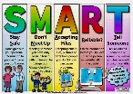    Computing: We will be following our computing scheme learning about technology all around us, naming the basic parts of a computer and understanding how to use technology safely. | 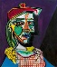  Art: We will look at different medias and materials to make marks, draw and explore making a variety of different styles of portraits, evaluating artwork by Picasso and Andy Warhol and saying what they like and do not like about the artwork. | 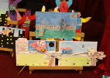  Design Technology: We will be investigating how a picture moves, creating a picture with moving parts and evaluating in small groups.
Autumn 2: Key Question: How has nursing changed from the past?
English: Throughout Autumn term, we will be focusing on handwriting, reading and comprehension skills, as well as grammar and punctuation. The development of quality vocabulary and learning how to construct a sentence, using a capital letter, finger spaces and a full stop will be the key focus. This will extend onto using a range of conjunctions within sentences and beginning to use adjectives.  We will be following the Little Wandle scheme  of learning for Phonics. | Maths: We will use the White Rose scheme of work to focus on number and place value. We will be learning to count, read and write to and across 100, forwards and backwards, beginning with 0 or any given number.  We will use a variety of practical objects to identify, sort and represent numbers to gain a deep understanding of number composition. | Science: We are learning all about the human body identifying, labelling, drawing and naming the basic parts of the body. We will say which part of the body is associated with each sense. Throughout the year we will be observing the different seasons too!
  History: We are learning all about describing similarities and differences between life during a time in the past and life today and how nursing has changed. The nurses we will be looking at are: Florence Nightingale, Edith Cavell and Mary Seacole. | Geography: We will be asking questions about the local area and drawing maps of real life and made up places through cross-curricular activities. We will be locating where our famous nurses came from and which countries they had significant impact on. | Music: We will be exploring the differences between pulse, rhythm and pitch and learn how to rap in its original form. This is following our Charanga scheme of music.
P.E: In PE this term, we will be developing our  running, jumping, throwing, catching, balance and agility skills. | R.E: We will be learning about Christianity and how Christians show that they belong to a faith and what it means to belong. We will look at the importance of baptism, God, the bible being a special book for Christians. As well as, visiting churches in the local area. | PSHE: In PSHE, following the scarf scheme of work we will be focusing on understanding rights and responsibilities, relationships and valuing differences.
Computing: We will be following our computing scheme learning about technology all around us, naming the basic parts of a computer and understanding how to use technology safely. | Art: We will look at different medias and materials to make marks, draw and explore making a variety of different styles of portraits, evaluating artwork by Picasso and Andy Warhol and saying what they like and do not like about the artwork. | Design Technology: We will be investigating how a picture moves, creating a picture with moving parts and evaluating in small groups.

