Dawlish Drive
Ruislip Manor
Middlesex
HA4 9SF
Tel: 01895 634180/ 01895 634318
Email: office@ladybankes.school
Website: www.ladybankes.school
Headteacher: Mrs K Needs

21st April 2023

Dear Lady Bankes families,

We will be celebrating the coronation of King Charles III at school on Friday 5th May.
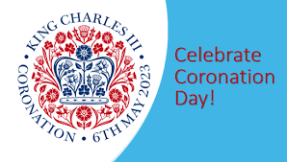
During the day the children will be completing activities in class relating to the coronation including crown making.

We will be having a picnic lunch on the playground so please keep your fingers crossed that the sun will be shining! Please remember to order this special lunch on ParentPay in advance.

After lunch we will be holding our own coronation concert like the one scheduled to take place at Windsor Castle. All our year groups, from Nursery to Year 6, will be performing songs from the coronation playlist to the other year groups. It should be a fun-filled afternoon.

We would very much like the children to wear red, white and blue clothes on that day rather than their school uniform.

We look forward to the children celebrating this special event at school.

Kind regards

Mrs Needs

