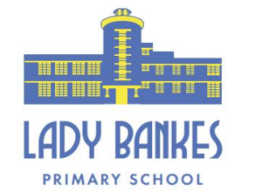

Dawlish Drive
Ruislip Manor
Middlesex
HA4 9SF
Tel: 01895 634180/ 01895 634318
Email: office@ladybankes.school
Website: www.ladybankes.school
Headteacher: Mrs K Needs
20th April 2023

Industrial Action by members of the National Education Union (NEU)

Dear Lady Bankes families,
The NEU is continuing their industrial action this term. Strikes are due to take place in schools across the country on the following days:
Thursday 27th April and Tuesday 2nd May

The situation continues to be different at every school and every Headteacher has different things to consider in terms of staffing, children and the school site. No school is the same in how they have made arrangements during industrial action.

As before members of the NEU are not required to let the school know in advance whether they are taking industrial action but kindly some members of our staff have again. As a result, we will have to close the following classes on Thursday 27th April and/or Tuesday 2nd May:

Class | Thursday 27th April | Tuesday 2nd May
1AM | Closed | Closed
1US | Closed | Closed
2HF | Open | Closed
2ED | Open | Closed
2KB | Open | Closed
4KS | Closed | Closed
4BH | Closed | Closed
6LM | Closed | Closed
6BM | Closed | Closed

This decision to close classes has not been taken lightly but following a careful risk assessment, through consultation with governors and in light of Department for Education guidance.

If your child has an Education, Health and Care plan, and is in one of the classes who are closed on these days, your child will be able to attend school and we will be contacting families for whom this applies.

As before, for children not in school there are plenty of learning activities that can be done at home. Children can access our online learning platforms including Bug Club, TT Rockstars and Mathletics. Each year group has home learning tasks which can be completed. The children also have spellings to learn and they should continue their daily reading.

We continue to recognise that this is a challenging situation for everyone and that some of our families will have to make alternative arrangements for your child/ren and thank you for your understanding.

Kind regards

Mrs Needs

