

Dawlish Drive
Ruislip Manor
Middlesex
HA4 9SF
Tel: 01895 634180/ 01895 634318
Email: office@ladybankes.school
Website: www.ladybankes.school
Headteacher: Mrs K Needs

15th June 2023


Dear Lady Bankes families,

I hope that you are all enjoying the lovely weather.
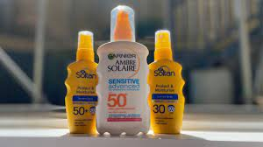

I would like to remind our families that we recommend that you apply sun cream to your child before they come to school on hot days like those that we are experiencing at the moment. Children are given the opportunity to reapply sun cream themselves before lunch, or more frequently if necessary, and so if you wish your child to do this you will need to send sun cream for them into school clearly labelled with their name. For younger children please practice applying sun cream at home as we are not able to do that for them. We also recommend children having hats with them.

We constantly risk assess the conditions when it is hot, particularly as shaded areas are quite limited, and if we think it is too hot we do limit the amount of time the children spend outside. We also follow the ‘advice for schools and other educational settings during a heatwave’ by the Department for Education.

We make every effort to ensure that the conditions at school are as comfortable as possible for both children and staff.

Kind regards

Mrs Needs

