Dates to remember:
Date | Event
19th February 2024 | Return to school
Thursday 7th March | World Book Day
WB 11th March | Science Week
Friday 15th March | Y4 Anglo Saxon / Viking Day
Friday 15th March | Red Nose Day
WB Monday 20th March | Round 2 Times Table Rock Stars
Friday 22nd March | FOLBA Disco
Thursday 28th March | Term Ends @ 2pm

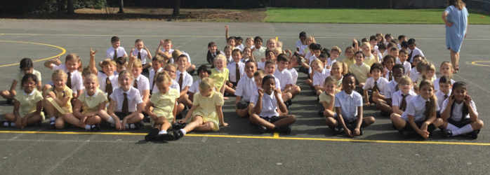

Don’t forget to keep checking our school X page (formerly known as Twitter), for recent photographs of school activities and sporting events.

@lady_bankes

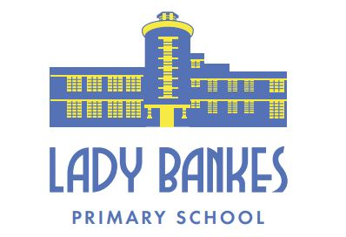

Year 4 Newsletter
Spring Term
Edition 4
Dear Lady Bankes families,
Welcome back after a well-deserved break. The children have returned to school refreshed and ready for the new learning and challenges ahead. We look forward to a positive and productive Spring Term where the children will have plenty of opportunities to enhance their knowledge of the Year 4 curriculum.
The Year 4 team
We are starting this half term focusing on a new Topic; Anglo Saxons and Vikings. We will be working hard to learn more about this fascinating period and think about answering our key question:
Who were the Anglo-Saxons and Vikings and why did they invade and settle in Britain?

Spellings


This year, the children have been given spelling books where they need to record sentences for each of their spelling words for that week. Please also use this QR code to find the statutory word list for Year 3 and 4 (page16). These are words frequently used and often misspelled in pupils’ writing. When we moderate the children’s writing, we check that these words especially are spelt accurately.

Home learning timetable
 | Handed out | Due in
Spellings | Weekly – sentences to be written into spelling books
Maths | Wednesday | Wednesday
Bug Club | One book a week*  *If the book is in excess of 40 pages this can be read over a 2 week period.
Reading | Minimum of five times per week. Please ensure the children’s Reading Records are signed and dated after they have read.

Reading log
We expect the Year 4 children to read for a minimum of five times a week. Please can this be recorded and signed by a parent or carer in their reading logs.

Times Tables Rock Stars

Congratulations to the following children for getting past round 1 and reaching the Year 4 Times Tables Rock Star final: Victoria, Oscar, Thea, Luke, Shashin, Nikki, Ronan, Julian, Joanna, Omar, Tristan, Toni, Casiana and Noorulain. The Year 4 final will take place in the week beginning 20th March.

Year 4 –Viking / Anglo Saxon Workshop – Portals to the Past

On Friday 15th March we have organised for the children to have a visit from Portals to the Past to support our current topic the Anglo Saxons and Vikings. The cost of the workshop is £5.92 per child (via ParentPay). This workshop covers a wide spectrum of Viking and Saxon life and times, from home-life to navigation, Gods to battles and having Viking fun. From invaders to settlers, Portals to the Past’s popular Viking Workshop really does bring this fascinating period of history to life for children. During the workshop children will:

- Learn how to play Fox and Geese, a Viking / Saxon board game
- A performance of the famous Beowulf story
- A Saxon / Viking quiz
- A weapons and armour display
- Viking Life and times
- Viking home-life and artefacts
We encourage the children to dress up in traditional Anglo Saxon or Viking clothing if they wish. Please see below for some ideas. We will also send a separate email to parents and carers with additional costume ideas:


