A guide to using Google Classroom

1) Type in Google Classroom and select.

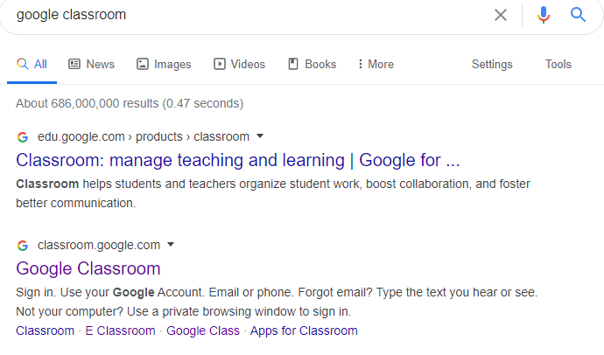
2) Select the + icon in the top right hand corner.
If this is the first time you are logging in you will need to select the join a class option.
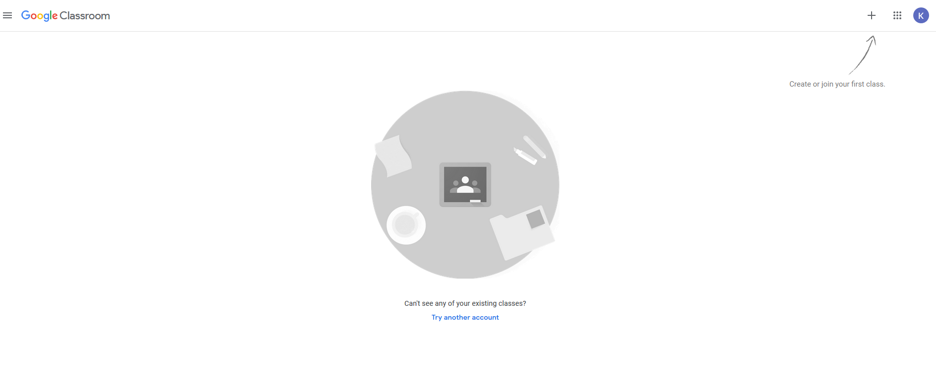

3) Login using your username and password.

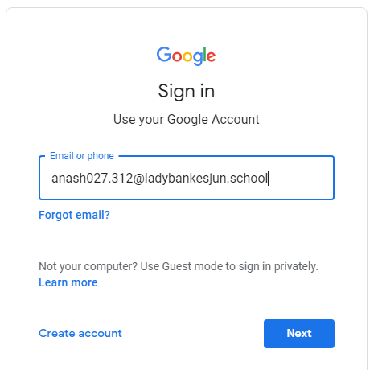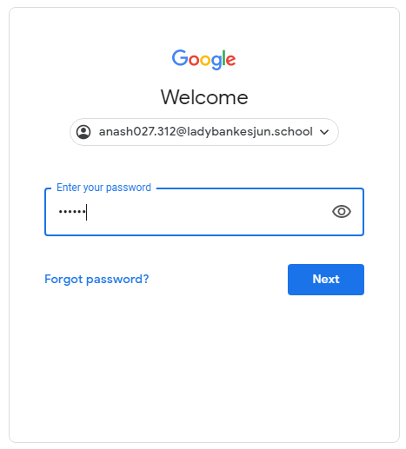

4) Select your class.
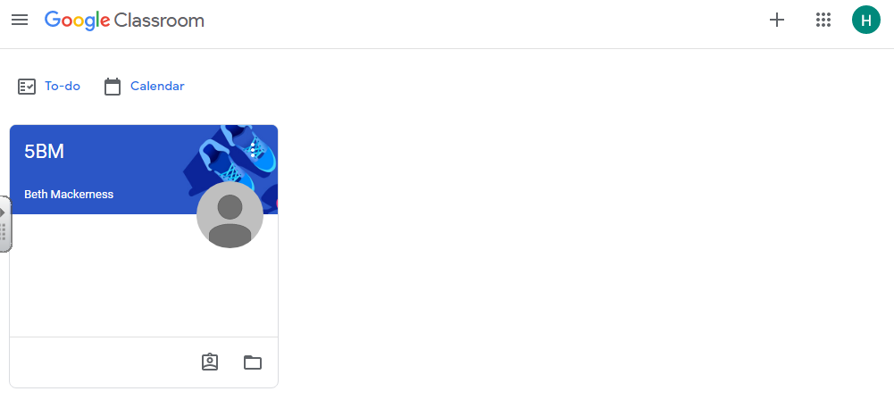

5) This will lead you to the stream and you can see if your teacher has posted anything for you.
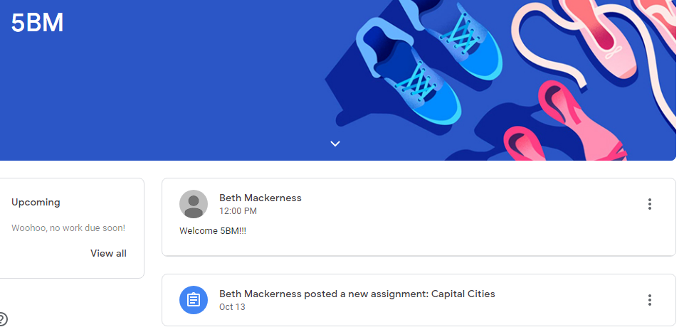

6) Click Classwork and you will be able to see the assignments that you are expected to complete.
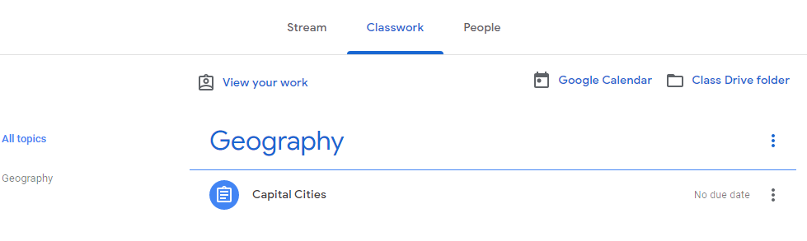
7) Select the task and then click view assignment.

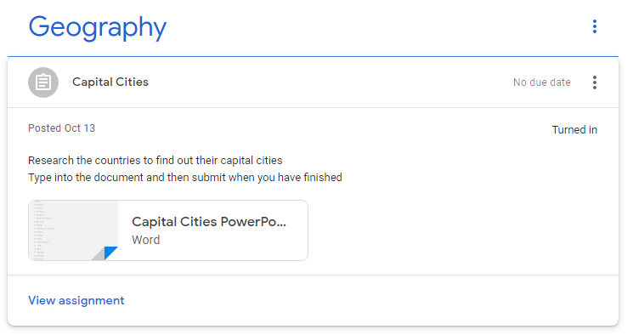

7) On this page you can read the instructions for the task and message your teacher privately. You can message throughout any point of your assignment if you are stuck. If you want to, you can also message once you have completed the assignment to tell your teacher how you got on.

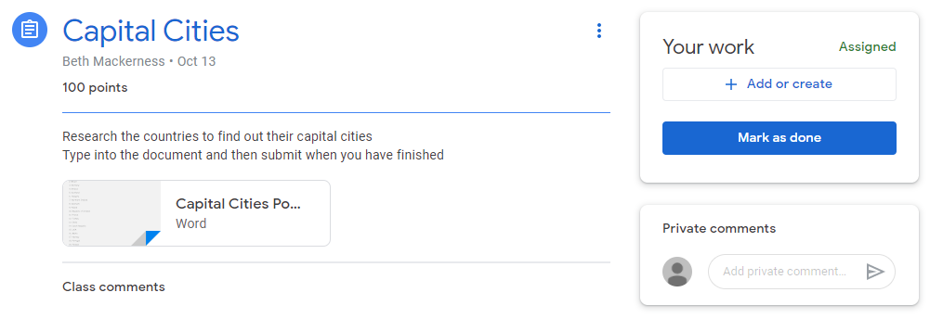
8) Once you click on the assignment you will be shown a preview of the task. Click ‘Open with Google Docs’ to start editting the assignment.

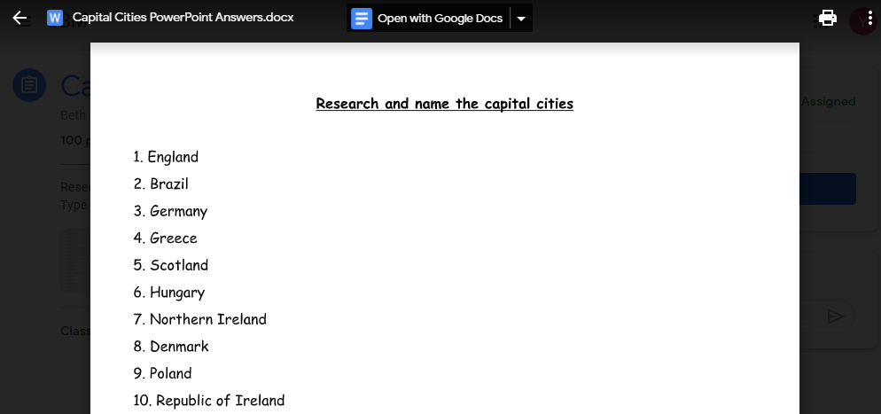
9) You can now start to complete the task. You do not need to click save as Google Docs will automatically save your work to your Google Drive. Once you have completed the work, you simply need to close the tab to return to the ‘Classwork’ page.
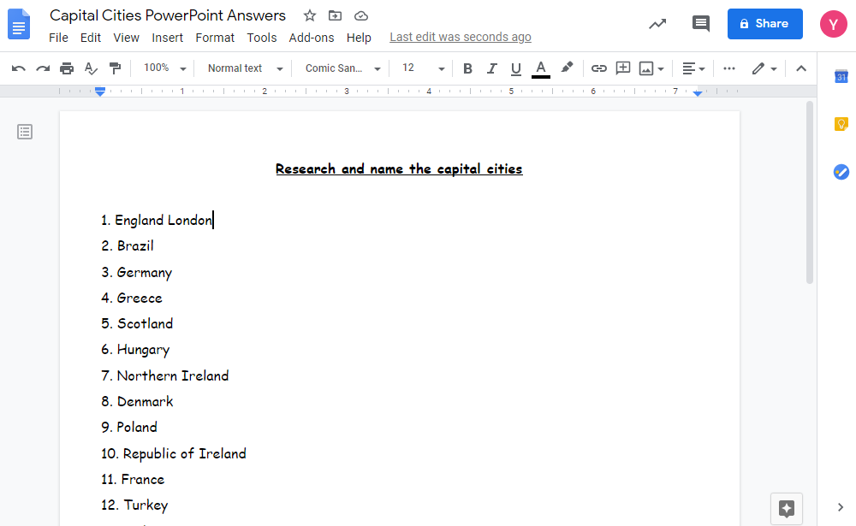

10) You will be brought back to this page. Just click the arrow to close the preview.

11) To assign your completed work, click the ‘+ Add or create’ button. Remember to message your teacher if you want to let them know how you got on with the task
[Grab your reader’s attention with a great quote from the document or use this space to emphasize a key point. To place this text box anywhere on the page, just drag it.]
12) Click ‘Google Drive’ and this will direct you to where your work has been saved. Click the work, then insert. Or simply double-click the work you want to upload.

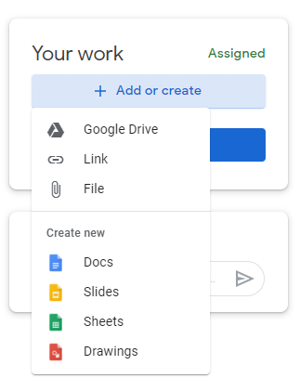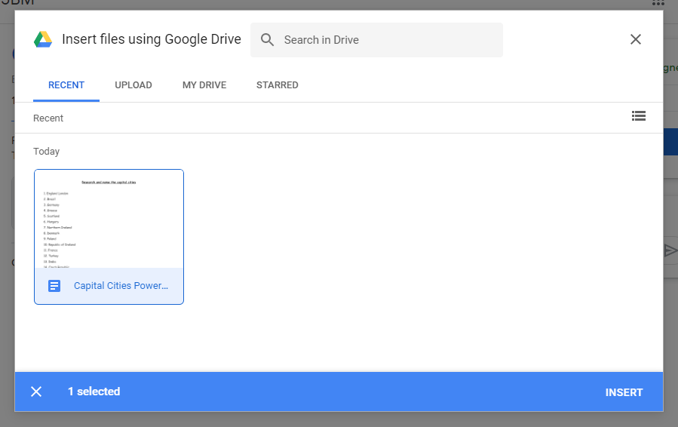

13) Your work has been inserted, you now need to click ‘Turn in’. This will send your work to your teacher for them to comment on and mark.

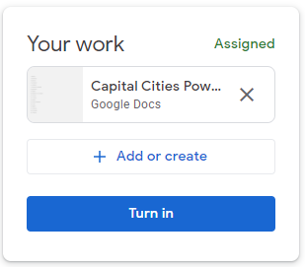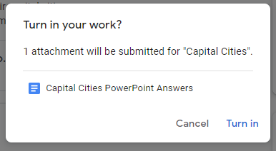

14) When you refresh the page you will able to see your teacher’s comment on your work.

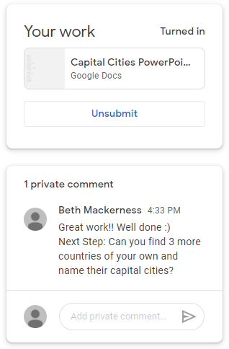
[Grab your reader’s attention with a great quote from the document or use this space to emphasize a key point. To place this text box anywhere on the page, just drag it.]

