Lady Bankes Primary School Remote Learning Plan

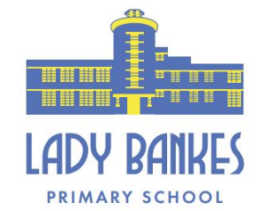
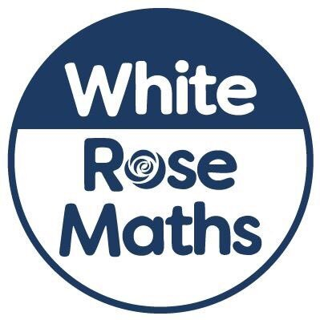
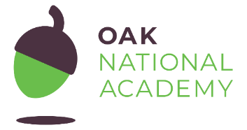



In order to ensure that learning is continued, irrespective of lockdown and self-isolation, Lady Bankes Primary School has developed the following plan. This plan offers remote learning opportunities whilst also acknowledging that some households have limited access to devices and could require paper copies of work and resources.
This plan will be applied in the following instances:
- An individual is self-isolating because of a positive test within the household or because they are complying with clinical or public health advice;
- A whole year group is self-isolating because of an outbreak or confirmed case of coronavirus;
- The school is closed to most children in the case of a local or national lockdown
The plan complies with the expectations and principles outlined in the DFE document Guidance for Full Opening of Schools.
Software and online platforms
Within all plans, teachers will set appropriate work in line with our current curriculum, primarily supplemented by a range of resources including those provided by Oak Academy and White Rose Maths.
Children will remain in contact with their class teachers through the use of the year group email and through Google Classroom:
nursery@ladybankes.school
reception@ladybankes.school
Year1@ladybankes.school
Year2@ladybankes.school
Year3@ladybankes.school
Year4@ladybankes.school
Year5@ladybankes.school
Year6@ladybankes.school

Oak Academy has been selected to support remote learning for a number of reasons. The Oak Academy lessons are in-line with our teaching ethos – they encourage the use of retrieval practice, explicit teaching with high quality modelling, and the use of deliberate practice. The online lessons are free to all and offer a recorded taught session so that the children can access physical teaching from a teacher and then access work relating to that lesson within the same website. Class teachers will be using some of the lessons in the classroom so that the children become familiar with the platform.
White Rose Maths will be used as this is our maths scheme and so the children will be very used to seeing these resources.
TT Rockstars will be utilised from Year 2 upwards to support the acquisition and retention of basic core skills in times tables.
Google Classroom will be used to provide daily online learning and also the opportunity for the children to communicate with their teachers. If there are significant numbers of pupils in a year group, or a whole year group not in school, the children will be set a daily timetable of online lessons to be completed. These lessons can be completed at the family’s convenience during the day as we know that some families will be needing their computers to work from home. Each day the children will have learning appropriate to their year group, which could include a Maths and English lesson and one other subject, reflecting the key question for that term. Live lessons will be provided if appropriate to the circumstances of an isolation.
In the event of any form of isolation and loss of learning caused by Coronavirus, parents must understand that engagement in home learning is essential, as is the expectation that Lady Bankes Primary School makes that provision available and accessible to all. However, if children themselves are too ill to attend then they should not be expected to engage in home learning.
In preparation for home learning, parents and children will receive logins and passwords for the following platforms:
- Google Classroom
- Mathletics
- Bug Club
- TT Rockstars

Remote Learning
The initial response to any isolation will be to provide children with home learning materials and access to online learning platforms. In the case of a large number of pupils in a year group or a whole cohort isolation, resources will be uploaded to Google Classroom and priority children will have packs delivered. This measure will afford teachers a short time to prepare their remote learning resources.
An individual pupil is self-isolating because of a positive test within the household or because they are complying with clinical or public health advice
Ongoing Support | Safeguarding/SEND
Pupil to be assigned work to be completed on Google Classroom, Mathletics and/or Bug Club.  Pupil to also complete basic skills practice on TT Rockstars if appropriate.  Pupil to be emailed or sent out a work pack of learning that reflects what is being completed in class.  If appropriate pupil to be directed to sections of lessons on Oak Academy and White Rose Maths that reflect the learning being completed in class. | School office to contact parents to ensure a test has been taken and to make sure that parents know to communicate test results to office@ladybankes.school  If child is vulnerable in any way, the DSL will ensure that appropriate agencies are notified. SENDCO will contact any families where pupils have an EHCP.  If a child does not engage, the class teacher will contact the parents to discuss any obstacles and support the school can give.

A group of children from a year group are self-isolating or are complying with clinical or public health advice
Ongoing Support | Safeguarding/SEND
Using Google Classroom, the year group teachers will upload lessons in advance when possible to allow parents time to see the learning materials prior to supporting their child. The teachers will decide what materials are most appropriate for the individual child.  Children will be assigned learning appropriate to their year group which could include a Maths and English lesson and another subject each day and learning will reflect what their peers are doing in school.  The lessons uploaded will either be school-bespoke PowerPoints or be taken from Oak Academy, BBC Bitesize or White Rose Maths.  Children should upload their completed learning and one of the pieces will be given feedback. All pieces of learning uploaded will be acknowledged. | School office to contact parents to ensure a test has been taken and to make sure that parents know to communicate test results to  office@ladybankes.school  If any child is vulnerable in any way, the DSL will ensure that appropriate agencies are notified. SENDCO will contact any families where pupils have an EHCP.  If a child does not engage, the year group leader is to contact the parents to discuss any obstacles and support the school can give.

A whole bubble/cohort of children is isolating because of an outbreak of coronavirus or the school is closed to most pupils due to a local or national lockdown
Ongoing Support | Safeguarding/SEND
Using Google Classroom, the year group teachers will upload lessons in advance where possible to allow parents to see the learning materials prior to supporting their child. The teacher will decide what materials are most appropriate for the individual child.  Children will be assigned learning appropriate to their year group which might include a Maths and English lesson and another subject each day. The learning will reflect what the lessons would have been were the children to have been in school. The children will also be asked to complete physical activities, a project and spend time on the school learning platforms including Bug Club and Mathletics. This will provide the children with 4 hours of learning daily.  The lessons uploaded will either be school-bespoke PowerPoints or be taken from Oak Academy, BBC Bitesize or White Rose Maths.  Children should upload their completed learning and detailed feedback will be given for all English and Maths activities. All pieces of learning uploaded will be acknowledged.  The school will organise a Google Meet weekly so that the group of children not in school will be able to see their peers and complete social activities. Year group daily check-ins will take place on Google Meet every day, ten minutes before the start of the school day so that teachers can explain the learning set and answer any queries.  Live lessons may take part if it is appropriate.  In the event of teachers becoming ill, the other teachers in the year group will oversee Google Classroom. | Parents notified so they know to communicate test results to office@ladybankes.school  If any child is vulnerable in any way, the DSL will ensure that appropriate agencies are notified. SENDCO will contact any families where pupils have an EHCP.  Those not engaging with home learning will receive a phone call from a member of SLT to discuss any obstacles and what support is needed for the family.  Where children would normally receive additional support from SEND agencies, the SENDCO will make arrangements for those to continue where possible.

